OBJECTIVE ABOUT THE TEAM
- To deploy the AUV as an “Automated Underwater Vehicle”, The Dream Team is a special cell of Team Hydra, Headed by
which will also be deployed as a ‘Purifier’. Siddhant bajpai(Team Head), Nishant srivastava(Opertaion
To also develop the AUV for surveying Head) and other members which is dedicated towards making
and navigation purpose. To develop it the AUV into a commercially viable product.
supporting the initiatives such as Working in collaboration with the government of India ,
‘SWACHH BHARAT ABHIYAN’ and the dream team aims at manufacturing a feasible product by ‘MAKE IN INDIA’, this shall comply the end of year 2017
with the modern day market requirements.
FACULTY ADVISOR
Dr. Prasanna Kumar
Professor, EIE
ACTIVITIES ACHIEVEMENTS
- Design and fabrication of the outer structure of auv. 1. Participation at NIOT competition at Chennai.
- Developing android application to monitor and control. 2. Secured second place in PDR presentation at
the auv. NIOT, Chennai.
- The hardware implementation of the electronics part. 3. Received the Best project award from IISc Bengaluru.
- Planning the underwater communication . 4.Working in collaboration with Government of India
- Lake water sample collection and testing. under two projects.
- Simulation. a)Autonomous underwater vehicle.
b)Autonomous Underwater Purifier.

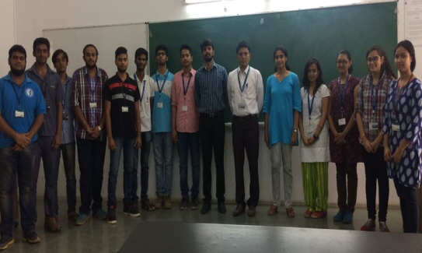
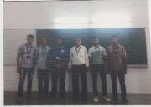
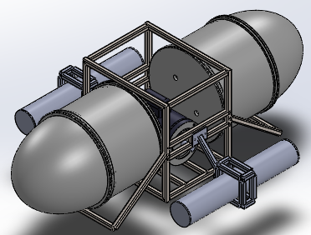
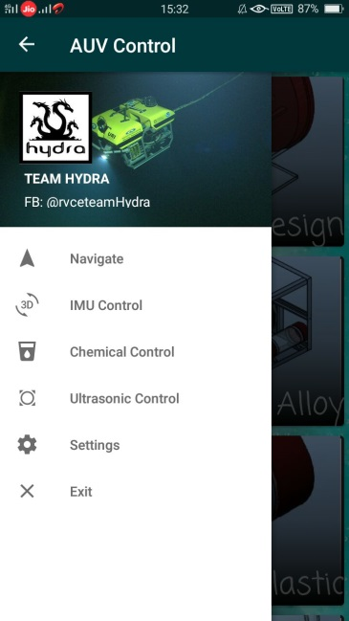
App UI: NEW DESIGN :

