NSS-office Bearers
NSS OFFICERS FOR THE ACADEMIC YEAR 2022-23
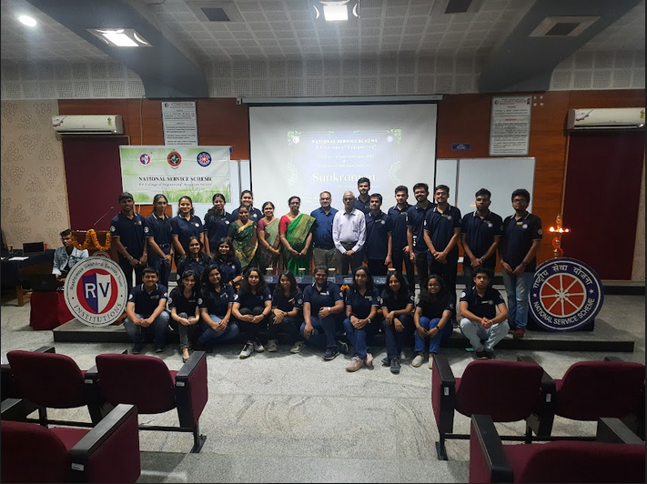

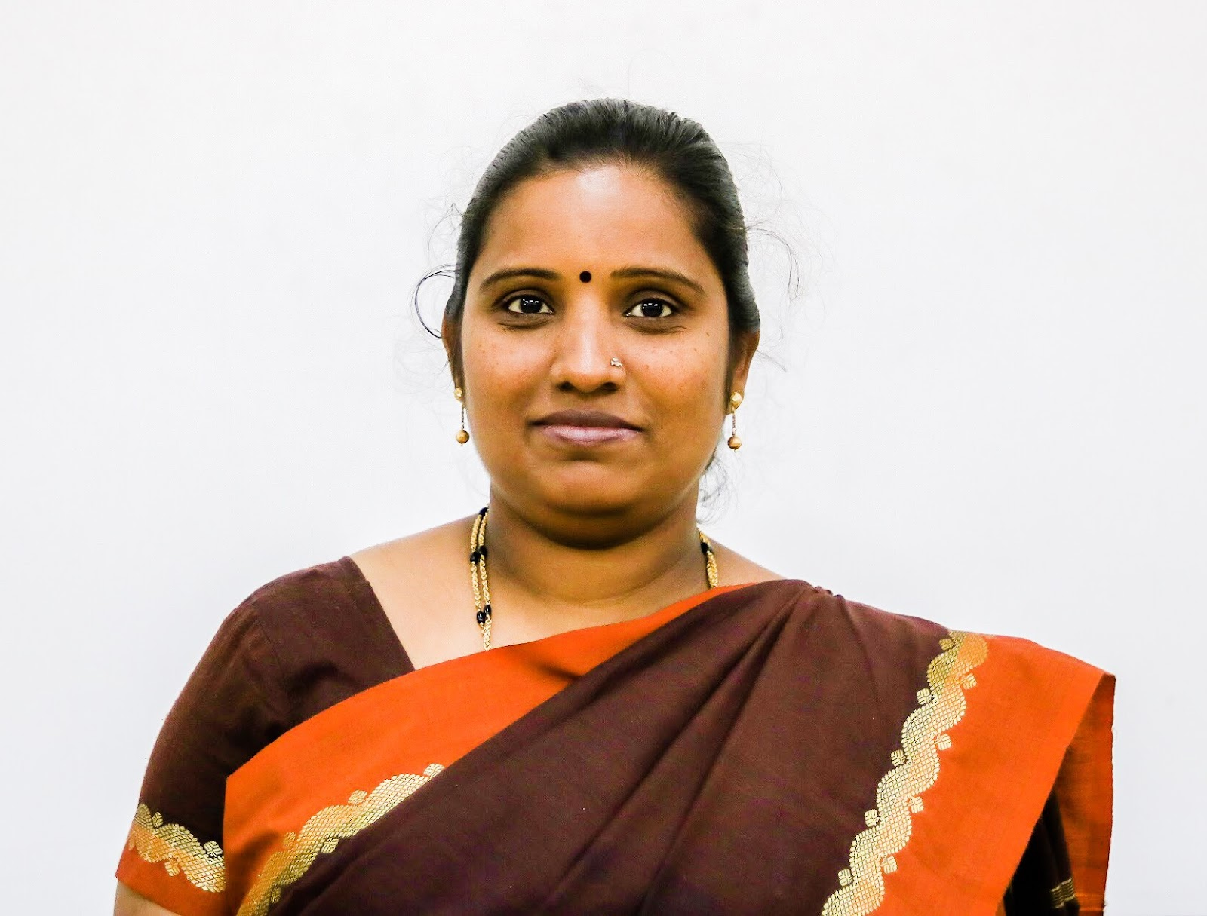
Dr. M LOKESHWARI
ASSOCIATE PROFESSOR
DEPT. OF CIVIL ENGG.
CONTACT DETAILS: +91-9741214628
EMAIL: lokeshwarim@rvce.edu.in
BHASKAR M.G  ASSISTANT PROF.  DEPT. OF INDUSTRIAL ENGG. AND MANAGEMENT  CONTACT DETAILS: +91-8553948300  EMAIL: bhaskarmg@rvce.edu.in | AJAY K.M  ASSISTANT PROF.  DEPT. OF ELECTRICAL AND ELECTRONICS  CONTACT DETAILS: +91-9964195810  EMAIL: ajaykm@rvce.edu.in
CORE TEAM 2022-2023
Srushti K  Arpitha R S  Harish N | President  Vice president  Secretary
Yashasvi Sorapalli  Sreerama Sai Lahari | Social Media and Content Heads
Nehashri Poojar S V  Rajule Harish Bhagirath  Yashaswini M R | Graphic Design and Development Heads
Siddharth kaushik L S  Bhoomika R Holla | Human Resource Heads
Vivek Pant  Prateeksha G  B M Dhanush | Operations Heads
Bindu Raaj  Nishanth Upadhyay | Public Relation Heads
Vivek Pant  Mohan P  Bindu Raaj | Volunteer development Heads
Pranav Sharma N  Mohan P  Charusmitha C | Village development Heads
Prajwal M S | ASPIRE Head
Divya A Kittur  Himapriya K N | Women empowerment Heads
Prajwal M S  Sumanth Patil | Environmental activities Heads
Neelesh Adki  Yuvraj T Rayamane  Durga Sitalakshmi S  K Srujana | Community services Heads

