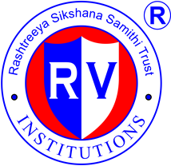
R.V.COLLEGE OF ENGINEERING
(Autonomous Institution Affiliated to VTU, Belagavi)
R.V. Vidyaniketan Post, Mysore Road
Bengaluru – 560 059

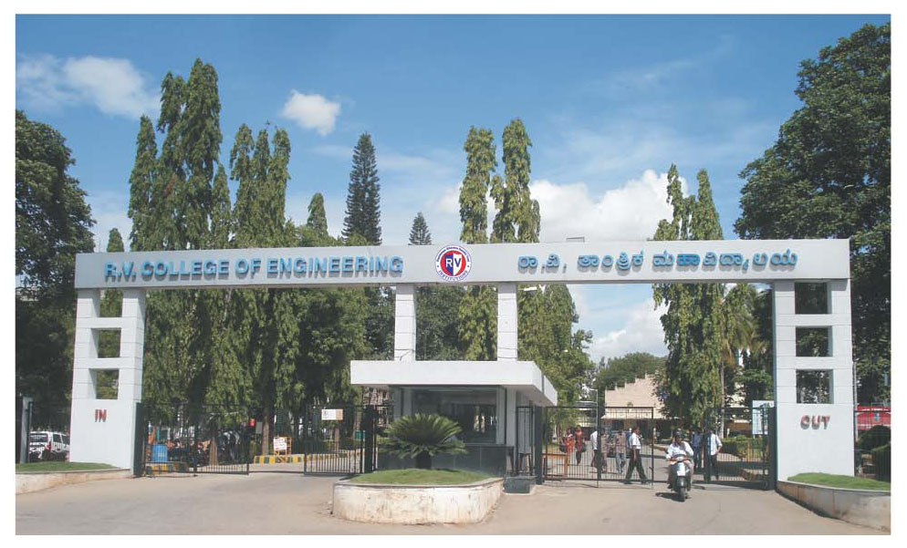
Bachelor of Engineering (B.E)
Scheme and Syllabus for III & IV Semesters

2016 SCHEME

AEROSPACE ENGINEERING
Department Vision
Emerge as a centre of excellence in Aerospace Engineering, Imparting Quality Technical Education, Interdisciplinary Research & Innovation with a focus on Societal empowerment through Sustainable & Inclusive Technologies.

Department Mission
- Imparting Quality Technical Knowledge in Basic & Applied areas of Aerospace Engineering incorporating the principles of Outcome Based Education.
- Provide state-of-the art laboratories and infrastructure facilities, conducive to motivate Interdisciplinary Research and Innovation in Aerospace Engineering.
- Develop self motivated engineers with a blend of Discipline, Integrity, Engineering Ethics and Social Responsibility.
- Strengthening collaboration with industries, research organizations and institutes for Internships, Joint Research And Consultancy.
- Focus towards Integrating Sustainable and Inclusive Technologies for Societal Symbiosis.

PROGRAM EDUCATIONAL OBJECTIVES (PEOs)

PEO1: To provide opportunities for successful professional career with a sound fundamental knowledge in Mathematics, Physical Science & Aerospace Engineering.

PEO2: Motivate innovative research in specialized areas of Aerospace Engineering viz Aerospace structural design, Aerodynamics, Aerospace Propulsion and Guidance & Control systems.

PEO3: Promoting development of problem solving abilities by adopting analytical, numerical and experimental skills with awareness on societal impact.

PEO4: Imbibing sound communication skills, team working ability, professional ethics and zeal for lifelong learning.

PROGRAM SPECIFIC OUTCOMES (PSOs)

PSO | Description
PSO1 | Utilization of the fundamental knowledge and skills of Aerospace Engineering to develop pragmatic solutions for complex Aerospace Engineering problems.
PSO2 | Apply Professional Engineering practices and strategies in the development of systems and subsystems for Aerospace Applications.
PSO3 | Exhibit Effective Communication skills and a Zeal to function with multi-disciplinary teams
PSO4 | Demonstrate Professional Ethics and Responsibilities in Engineering practices towards the achievement of societal symbiosis.
R.V.COLLEGE OF ENGINEERING
(Autonomous Institution Affiliated to VTU, Belagavi)
R.V. Vidyaniketan Post, Mysore Road
Bengaluru – 560 059

Bachelor of Engineering (B.E)
Scheme and Syllabus for III & IV Semesters

2016 SCHEME

AEROSPACE ENGINEERING
Abbreviations
Sl. No. | Abbreviation | Meaning
 | VTU | Visvesvaraya Technological University
 | BS | Basic Sciences
 | CIE | Continuous Internal Evaluation
 | CS | Computer Science and Engineering
 | CV | Civil Engineering
 | CHY | Chemistry
 | EC | Electronics and Communication Engineering
 | EE | Electrical and Electronics Engineering
 | ES | Engineering Science
 | HSS | Humanities and Social Sciences
 | ME | Mechanical Engineering
 | PHY | Engineering Physics
 | SEE | Semester End Examination
 | MAT | Engineering Mathematics

INDEX
III Sem
Sl. No. | Course Code | Name of the Course | Page No.
 | 16MA31C | Applied Mathematics-III | 01
 | 16EM32B | Engineering Materials | 03
 | 16AS33 | Introduction to Aerospace Engg | 05
 | 16AS34 | Thermodynamics | 07
 | 16AS35 | Mechanics of Fluids | 10
 | 16AS36 | Structural Mechanics | 13
 | 16MA37 | Bridge course Mathematics-I | 15
IV Sem
 | 16MA41C | Applied Mathematics-IV | 17
 | 16ET42 | Environmental Technology | 19
 | 16AS43 | Aerodynamics | 21
 | 16AS44 | Aerospace Structures | 24
 | 16AS45 | Kinematics & Dynamics of Machines | 26
 | 16AS46 | Manufacturing Technology | 28
 | 16HS47 | Professional Practice-II $ | 31
 | 16DCS48 | Bridge Course in C Programming | 33
R V COLLEGE OF ENGINEERING, BENGALURU-560 059
(Autonomous Institution Affiliated to VTU, Belagavi)
DEPARTMENT OF AEROSPACE ENGINEERING
THIRD SEMESTER CREDIT SCHEME
Sl. No. | Course Code | Course Title | BoS | CREDIT ALLOCATION
 |  |  |  | L | T | P | S | Total Credits
 | 16MA31C | Applied Mathematics-III | MAT | 3 | 1 | 0 | 0 | 4
 | 16EM32 | Engineering Materials | ME | 2 | 0 | 0 | 0 | 2
 | 16AS33 | Introduction to Aerospace Engg | AS | 3 | 0 | 0 | 1 | 4
 | 16AS34 | Thermodynamics | AS | 3 | 0 | 1 | 1 | 5
 | 16AS35 | Mechanics of Fluids | AS | 4 | 0 | 1 | 0 | 5
 | 16AS36 | Structural Mechanics | AS | 3 | 0 | 1 | 1 | 5
 | 16MA37 | Bridge course Mathematics-I* | MAT | 2 | 0 | 0 | 0 | 0
Total number of Credits |  |  |  | 20 | 1 | 3 | 3 | 25
Total Number of Hours / Week |  |  |  | 18+2* | 2 | 6 | 12**

FOURTH SEMESTER CREDIT SCHEME
Sl. No. | Course Code | Course Title | BoS | CREDIT ALLOCATION
 |  |  |  | L | T | P | S | Total Credits
 | 16MA41C | Applied Mathematics-IV | MAT | 3 | 1 | 0 | 0 | 4
 | 16ET42 | Environmental Technology | BT | 2 | 0 | 0 | 0 | 2
 | 16AS43 | Aerodynamics | AS | 3 | 0 | 1 | 0 | 4
 | 16AS44 | Aerospace Structures | AS | 3 | 0 | 1 | 1 | 5
 | 16AS45 | Kinematics & Dynamics of Machines | AS | 3 | 0 | 0 | 1 | 4
 | 16AS46 | Manufacturing Technology | AS | 3 | 0 | 1 | 1 | 5
 | 16HS47 | Professional Practice-II | HSS | 0 | 0 | 1 | 0 | 1
 | 16DCS48 | Bridge Course in C  Programming * | CSE | 2 | 0 | 0 | 0 | 0
Total number of Credits |  |  |  | 17 | 1 | 4 | 3 | 25
Total Number of Hours / Week |  |  |  | 17+2* | 2 | 8 | 12**
*Mandatory Audit course for lateral entry diploma students
**Non-contact hours

APPLIED MATHEMATICS – III
(AS, BT, CH, CV, IM, ME)
Course Code: 16MA31C |  |  | CIE Marks: 100
Credits: L:T:P:S: 3:1:0:0 |  |  | SEE Marks: 100
Hours: 36L+12T |  |  | SEE Duration: 3Hrs
Course Learning Objectives:
1 | Identify and solve initial value problems, physically interpret the solution, using Laplace Transforms and Inverse Laplace transforms.
2 | Evaluate extremal of integrals involving functionals with applications to physical situations.
3 | Understand the basics of Matrix theory, Eigen values and Eigen vectors, its applications for finding solution of system of linear equations.
4 | Analyse the given set of experimental data and fit suitable approximating curves.

Unit-I
Laplace Transform: stence and uniqueness of Laplace Transform (LT), Transform of elementary functions, RoC. Properties of LT : Linearity, change of scale and first shifting. Transform of function multiplied by t^{n}, division by t, derivatives and integral. LT of periodic function, Heaviside unit step function, Unit impulse function. Heaviside shift (second shift) theorem. |  | 07 Hrs
Unit – II
Inverse Laplace Transform:  Definition, properties of inverse Laplace transform, evaluation using different methods. Convolution theorem, problems. Application to solve ordinary linear differential equations and simultaneous differential equations. |  | 07 Hrs
Unit -III
Calculus of Variation:  Introduction of variation of functions, extremal of a functional, Euler’s equation-special cases-problems. Geodesics-problems, Hanging cable problem, Brachistochrome problem. |  | 07Hrs
Unit –IV
Linear Algebra:  Rank of matrices-rank of matrix by Echelon form, consistency of system of linear equations- homogeneous and non-homogeneous equations, Gauss elimination, Gauss Jordan, Gauss Seidel methods, Eigen values and Eigen vectors-properties, largest Eigen value by Power method. |  | 08Hrs
Unit –V
Statistics:  Curve fitting by method of least squares, fitting of curves-linear, parabolic, exponential, power functions, correlation, regression analysis – problems. |  | 07 Hrs
Course Outcomes: After completing the course, the students will be able to
CO1: | Understand the fundamental concepts of Laplace and inverse Laplace transforms, variation of functions, elementary transformation of matrices, method of least squares.
CO2: | Demonstrate the properties of Laplace and inverse Laplace transforms, knowledge of extremal of functional, Eigen values, Eigen vectors and correlation.
CO3: | Apply Laplace and inverse Laplace transform technique to solve differential equations, Euler’s equation to solve variational problems, matrix methods to solve system of linear equations, regression analysis for curve fitting.
CO4: | Analyse and interpret- solution of IVP and BVP, solution of functionals, solution of linear systems, statistical data occurring in Engineering problems.
Reference Books
1 | Higher Engineering Mathematics, B.S. Grewal, 40th Edition, 2007, Khanna Publishers, ISBN: 81-7409-195-5.
2 | Higher Engineering Mathematics, B. V. Ramana, 6th Edition, 2008, Tata McGraw-Hill, ISBN: 13-978-07-063419-0.
3 | Advanced Engineering Mathematics, Erwin Kreyszig, 9th Edition, 2007, John Wiley & Sons, ISBN: 978-81-265-3135-6.
4 | Introduction to Probability and Statistics, Lipshutz and Schiller (Schaum’s outline series), ISBN:0-07-038084-8.

Continuous Internal Evaluation (CIE); Theory (100 Marks)
CIE is executed by way of quizzes (Q), tests (T) and Assignment. A minimum of three quizzes are conducted and each quiz is evaluated for 10 marks adding up to 30 marks. All quizzes are conducted online. Faculty may adopt innovative methods for conducting quizzes effectively. The number of quizzes may be more than three also. The three tests are conducted for 50 marks each and the sum of the marks scored from three tests is reduced to 60. The marks component for assignment is 10. The total marks of CIE are 100.

Semester End Evaluation (SEE); Theory (100 Marks)
SEE for 100 marks is executed by means of an examination. The Question paper for each course contains two parts, Part – A and Part – B. Part – A consists of objective type questions for 20 marks covering the complete syllabus. Part – B consists of five main questions, one from each unit for 16 marks adding up to 80 marks. Each main question may have sub questions. The question from Units I, IV and V have no internal choice. Units II and III have internal choice in which both questions cover entire unit having same complexity in terms of COs and Bloom’s taxonomy level.

CO-PO Mapping
CO/PO | PO1 | PO2 | PO3 | PO4 | PO5 | PO6 | PO7 | PO8 | PO9 | PO10 | PO11 | PO12
CO1 | 3 | 2 | - | - | - | - | - | - | - | - | - | 1
CO2 | 3 | 2 | - | - | - | - | - | - | - | - | - | 1
CO3 | 1 | 2 | 2 | - | - | - | - | - | - | - | - | 1
CO4 | - | 1 | 1 | 3 | - | - | - | - | - | - | - | 1

High-3 : Medium-2 : Low-1

Semester: III
ENGINEERING MATERIALS
Course Code: 16EM32B |  |  | CIE Marks: 50
Hrs/Week: L:T:P:S: 2:0:0:0 |  |  | SEE Marks: 50
Credits:2 |  |  | SEE Duration: 2 Hrs
Course Learning Objectives: The students should be able to
1 | Familiarize with atomic structure of metals, imperfections, diffusion mechanisms and  theories of plastic deformation
2 | Construct phase diagram of different alloy system
3 | Differentiate between steel and cast iron with the help of Iron carbon Diagram
4 | Explain Time Temperature Transformation diagram and different types of heat  treatment processes
5 | Explain composition, properties and application of ferrous and non-ferrous materials
6 | Explain concept of corrosion in materials and their prevention
7 | Select materials for automotive, aerospace, marine and domestic applications

UNIT-I
Crystallography, defects in materials and deformation:  Crystal structure - BCC, FCC and HCP structures - Unit cell - Crystallographic  planes and directions, Miller indices. Crystal imperfections, point, line, planar and volume defects - Grain size, ASTM grain size number. Frank Reed source of dislocation, Elastic and Plastic deformation, Slip and Twinning, strain hardening and Bauschinger effect | 06 Hrs
UNIT-II
Alloys and Phase Diagrams: Constitution of alloys - solid solutions -  Substitutional and Interstitial  Phase diagrams - construction of isomorphus phase diagram, Lever rule, Iron- Iron carbide equilibrium diagram, different types of invariant reactions, slow cooling of steels | 04 Hrs
UNIT-III
Heat Treatment: Full annealing, Stress relief annealing, Normalizing, Hardening  and Tempering of steel. Isothermal transformation diagram of eutectoid steel - cooling curves imposed on I.T diagram, Critical cooling rate, Hardenability, Jomminy end quench test - austempering, martempering, case hardening, carburising, nitriding, cyaniding. Flame and Induction hardening. | 06 Hrs
UNIT-IV
Ferrous and Non Ferrous Metals: Alloying of steel (Mn, Si, Cr, Mo, V, Ti and  W) - stainless steels and tool steels - High Speed Low alloy (HSLA). Cast Iron- Gray, white, malleable, spheroidal, graphite cast iron.  Composition, Properties and applications of Copper and Copper alloys-Brass and  Bronze, Aluminium and Aluminium alloys, Titanium and Titanium alloys. | 04 Hrs
UNIT-V
Corrosion: Types of corrosion- Galvanic corrosion, Pitting corrosion, Erosion  corrosion, Crevice corrosion; intergranular and transgranular corrosion, hydrogen cracking and embrittlement, corrosion prevention.  Materials for Automotive, aerospace, marine and domestic applications. | 04 Hrs

Course Outcomes: After completing the course, the students will be able to
CO1 | Understand the concepts of crystal structure, microstructure and deformation.
CO2 | Construct phase diagram of alloy systems and Iron Carbon phase diagram.
CO3 | Develop TTT diagram
CO4 | Select ferrous and Non-ferrous materials and their alloys for different application.

Reference Books
1. | Material Science and Engineering, William F Smith , 4th Edition, 2008, Tata McGraw Hill,  ISBN: 978-0-07-066717-4;
2. | Introduction to Physical Metallurgy, Sidney H Avner, 1997,Tata McGraw Hill,  ISBN: 978-0-07-463006-8;
3. | Materials Science and Engineering An Introduction, William D. Callister, Jr, 6th Edition, 2004,John Wiley and Sons, Inc., ISBN: 9812-53-052-5

Continuous Internal Evaluation (CIE); Theory (50 Marks)
CIE is executed by way of quizzes (Q), tests (T) and Assignment. A minimum of three quizzes are conducted and each quiz is evaluated for 05 marks adding up to 15 marks. All quizzes are conducted online. Faculty may adopt innovative methods for conducting quizzes effectively. The number of quizzes may be more than three also. The three tests are conducted for 25 marks each and the sum of the marks scored from three tests is reduced to 30. The marks component for Assignment is 05. The total marks of CIE are 50.

Semester End Evaluation (SEE); Theory (50 Marks)
SEE for 50 marks is executed by means of an examination. The Question paper for each course contains two parts, Part – A and Part – B. Part – A consists of objective type questions for 10 marks covering the complete syllabus. Part – B consists of five main questions, one from each unit for 08 marks adding up to 40 marks. Each main question may have sub questions. The question from Units I, IV and V have no internal choice. Units II and III have internal choice in which both questions cover entire unit having same complexity in terms of COs and Bloom’s taxonomy level.

CO-PO Mapping
CO/PO | PO1 | PO2 | PO3 | PO4 | PO5 | PO6 | PO7 | PO8 | PO9 | PO10 | PO11 | PO12
CO1 |  | H | L |  |  |  | M |  |  |  |  | L
CO2 | H | H | L |  |  |  |  |  |  | L
CO3 | M | H |  |  | M
CO4 |  | H | L |  |  | M |  |  |  |  |  | L

Low-1 Medium-2 High-3

Semester: III
INTRODUCTION TO AEROSPACE ENGINEERING
(Theory)
Course Code: 16AS33 |  | CIE Marks: 100
Credits: L:T:P:S: 3:0:0:1 |  | SEE Marks: 100
Hours : 36L |  | SEE Duration: 3Hrs

Course Learning Objectives:
To enable the students to:
1 | Understand the history and basic principles of aviation
2 | Demonstrate and explain foundation of flight, aircraft structures, material, aircraft propulsion
3 | Explain the working of each component of an aircraft
4 | Assess the stability of an aircraft along with its different systems

Unit-I
Introduction to Aircraft : History of aviation, Evolution of Aviation in India, International Standard atmosphere, Atmosphere and its properties, Temperature, pressure and altitude relationships, Classification of aircrafts, Anatomy of an aircraft & Helicopters, Basic components and their functions, V/STOL machines, Modern developments in Aviation.  Introduction to Space Flight : Evolution of spacecraft technologies, History of Indian Space Technology, The upper atmosphere, Introduction to basic orbital mechanics, Orbit equation, Space vehicle trajectories, some basic concepts, Kepler’s Laws of planetary motion. | 07 Hrs
Unit – II
Basic Aerodynamics : Bernoulli’s theorem, Aerodynamic forces and moments on an Airfoil, Lift and drag, Types of drag, Centre of pressure and its significance, Aerodynamic centre, Aerodynamic Coefficients, Wing Planform Geometry, Airfoil nomenclature, Basic characteristics of airfoils, NACA nomenclature, Simple problems on lift and drag. | 07 Hrs
Unit -III
Aircraft Propulsion : Introduction, Classification of powerplants, Piston Engine: Types of reciprocating engines, Brayton cycle, Principle of operation of turbojet, turboprop, and turbofan engines, Introduction to ramjets and scramjets, Comparative merits and demerits of different types Engines.  Rocket Propulsion : Principles of operation of rocket, Classification of Rockets, Types of rockets, Introduction to Space Exploration. | 07 Hrs

Unit -IV
Aircraft Structures and Materials : Introduction, General types of construction, Monocoque, Semi-Monocoque and Geodesic structures, Typical wing and fuselage structure; Metallic and non-metallic materials for aircraft application. Use of aluminum alloy, titanium, stainless steel and composite materials.  Aircraft Stability : Airplane Stability and Control, Airplane axis system, Forces and Moments about longitudinal, lateral and vertical axes, Equilibrium of forces developed on wing and horizontal tail, Centre of gravity, Its importance in stability and control, Control surfaces elevators, ailerons and rudder. | 08 Hrs
Unit -V
Aircraft Instruments : Instrument Displays, Introduction to Navigation Instruments, Basic Air data systems & Probes, Mach meter, Air speed indicator, Vertical speed indicator, Altimeter, Gyro based instruments.  Aircraft Systems : Introduction to Hydraulic and pneumatic systems, Air Conditioning and Cockpit pressurization system, Generation and distribution of Electricity on board the airplane, Aircraft Fuel System, Fire Protection, Ice and Rain Protection System. | 07 Hrs

Course Outcomes:
At the end of this course the student will be able to :
CO1 | Appreciate and apply the basic principles of aviation
CO2 | Apply the concepts of fundaments of flight, basics of aircraft structures, aircraft propulsion and aircraft materials during the development of an aircraft
CO3 | Comprehend the complexities involved during development of flight vehicles.
CO4 | Evaluate and criticize the design strategy involved in the development of airplanes

Reference Books
1 | Introduction to Flight, John D. Anderson, 7th Edition, 2011, McGraw-Hill Education, ISBN 9780071086059.
2 | Rocket Propulsion Elements, Sutton G.P., 8th Edition., 2011, John Wiley, New York, ISBH:1118174208, 9781118174203.
3 | Aircraft structural Analysis, T.H.G Megson, 4th Edition, 20013, Butterworth-Heinemann Publications, ISBN: 978-1-85617-932-4.
4 | Flight stability and automatic control, Nelson R.C, 2nd Edition, 1998, McGraw-Hill International Editions, ISBN 9780071158381.
5 | Aircraft Systems: Mechanical, Electrical and Avionics Subsystems Integration, Ian Moir, Allan Seabridge, 3rd Edition, 2008 , John Wiley & Sons,. ISBN 978111965006.

Continuous Internal Evaluation (CIE); Theory (100 Marks)

CIE is executed by way of quizzes (Q), tests (T) and Self-Study(S). A minimum of three quizzes are conducted and each quiz is evaluated for 10 marks adding up to 30 marks. All quizzes are conducted online. Faculty may adopt innovative methods for conducting quizzes effectively. The number of quizzes may be more than three also. The three tests are conducted for 50 marks each and the sum of the marks scored from three tests is reduced to 50. The marks component for Self-study is 20. The total marks of CIE are 100.

Semester End Evaluation (SEE); Theory (100 Marks)
SEE for 100 marks is executed by means of an examination. The Question paper for each course contains two parts, Part – A and Part – B. Part – A consists of objective type questions for 20 marks covering the complete syllabus. Part – B consists of five main questions, one from each unit for 16 marks adding up to 80 marks. Each main question may have sub questions. The question from Units I, IV and V have no internal choice. Units II and III have internal choice in which both questions cover entire unit having same complexity in terms of COs and Bloom’s taxonomy level.

CO-PO Mapping
CO/PO | PO1 | PO2 | PO3 | PO4 | PO5 | PO6 | PO7 | PO8 | PO9 | PO10 | PO11 | PO12
CO1 | 3 | 3 | 3 | 1 | 1 | 3 | 2 | 2 |  |  |  | 1
CO2 | 2 | 3 | 3 | 3 | 1 | 1 | 1 | 1 |  |  |  | 2
CO3 | 1 |  | 3 | 3 |  |  |  |  |  |  |  | 2
CO4 | 3 | 3 | 3 | 3 |  | 2 | 1 | 2 |  |  |  | 2

High-3 : Medium-2: Low-1

Semester: III
THERMODYNAMICS
(Theory & Practice)
Course Code: 16AS34 |  | CIE Marks: 100+50
Credits: L:T:P:S: 3:0:1:1 |  | SEE Marks: 100+50
Hours: 36L |  | SEE Duration: 03Hrs +03Hrs

Course Learning Objectives:
To enable the students to:
1 | Understand the influence of thermodynamic properties on processes
2 | Apply the thermodynamic laws in practical applications
3 | Evaluate the efficiencies and properties of thermodynamic systems
4 | Appreciate the practical applications of thermodynamics
5 | Build thermodynamic solutions for newly emerging technologies.

Unit-I
Fundamental Concepts : Introduction to Thermodynamics, Macroscopic and Microscopic Approach - Thermodynamic System, surroundings and boundary- Thermodynamic state, path, process, Thermodynamic Property, Intensive and Extensive properties, Path and Point Function, Quasi Equilibrium process.  Concept of Temperature: Zeroth Law of thermodynamics and temperature measurement, definition of work and its limitations, Thermodynamic definition of Heat and work. Heat and work transfer, expressions for displacement work in various processes through P-V diagrams. | 08 Hrs
Unit – II
Fist Law Thermodynamic: First Law of thermodynamics for Closed System, Concept of Internal Energy, Enthalpy, First Law of Thermodynamics for a closed system , Steady flow process, steady flow energy equation and applications, PMMK1  Second law of Thermodynamics: Limitations of First Law of thermodynamics, Heat engine, Heat pump, Carnot’s principle, Carnot cycle and its specialties, Clausius and Kelvin Planck statement, PMMK2, Entropy, Entropy change in non-flow processes. | 07 Hrs
Unit -III
Perfect Gas Laws: Equation of State, specific and Universal Gas constant, Mass and Mole Fraction, Properties of Gas Mixtures, Throttling and Free Expansion Processes, Deviations from perfect Gas  Gas Mixtures: Gas Model, Ideal gas mixture; Dalton’s laws of partial pressures, Amagat’s law of additive volumes, Vander Waal's Equation of State –compressibility factor, use of compressibility charts. | 08 Hrs

Unit -IV
Gas Cycles: Efficiency of air-Standard cycles-Carnot cycle, Otto, Diesel, Dual and Brayton cycle, Mean effective pressure, Representation of cycles on P-V and T-s diagrams.  Performance of I.C. Engines: Air and Fuel measurement, Calculation of IP BP & FP, and Heat Balance sheet calculations. | 07 Hrs
Unit -V
Psychrometry: Properties of atmospheric air, Construction and use of psychrometric chart, Analysis of various processes, heating, cooling, dehumidifying and humidifying, Adiabatic mixing of moist air, Analysis of various Air conditioning processes. | 06 Hrs

LABORATORY EXPERIMENTS
- Determination of flash point and fire point of the given fuels/lubricating oils using Abel Pensky and Pensky Martin's apparatus
- Determination of Calorific Value of Solid & Liquid Fuels using Bomb calorimeter
- Determination of Calorific Value of gaseous fuel using Junker gas calorimeter
- Determination of viscosity of various lubricating oils using Redwood, Saybolts Viscometers
- Determination of viscosity of various lubricating oils using Brookfield Viscometer
- Study of characteristics and performance of a 4 stroke Diesel Piston engine under various conditions
- Study of characteristics and performance of a 4 stroke Petrol Piston engine under various conditions
- Determination of Friction power using Morse test
- Determination of effectiveness of a parallel and counter flow heat exchangers
- Determination of constituents of a gas mixture using Orsat apparatus
- Study the performance of vapor compression air conditioning system
- Study the performance of vapor compression refrigeration system

Course Outcomes:
At the end of this course the student will be able to :
CO1 | Understand the concepts and definitions of thermodynamics
CO2 | Differentiate thermodynamic work and heat and apply I law and II law of thermodynamics to different processes
CO3 | Comprehend and utilize the principles of Refrigeration and air conditioning
CO4 | Design and Analyze the functioning of various Thermodynamic cycles

Reference Books
1 | Thermodynamics:An Engineering Approach, Yunus A.Cenegal and Michael A.Boles, 4th Edition, 2011, TataMcGraw Hill publications, ISBN: 9780070495036.
2 | Engineering Thermodynamics, J.B.Jones and G.A.Hawkins, 2nd Edition, 1986, John Wiley and Sons, ISBN: 978-0471812029.
3 | Fundamentals of Classical Thermodynamics, G.J.Van Wylen and R.E.Sonntag, 3rd Edition, 1986, Wiley Eastern, ISBN-13: 978-0-471-61075-5.
4 | Basic and Applied Thermodynamics P.K.Nag, 2nd Edition., 2002, Tata McGraw Hill Pub, ISBN-13: 978-0070151314.

Continuous Internal Evaluation (CIE): Total marks: 100+50=150

Theory – 100 Marks
CIE is executed by way of quizzes (Q), tests (T) and Self-Study(S). A minimum of three quizzes are conducted and each quiz is evaluated for 10 marks adding up to 30 marks. All quizzes are conducted online. Faculty may adopt innovative methods for conducting quizzes effectively. The number of quizzes may be more than three also. The three tests are conducted for 50 marks each and the sum of the marks scored from three tests is reduced to 50. The marks component for Self-study is 20. The total CIE for theory is 100.
Laboratory- 50 Marks
The Laboratory session is held every week as per the time table and the performance of the student is evaluated in every session. The average of marks over number of weeks is considered for 40 marks. At the end of the semester a test is conducted for 10 marks. Total marks for the laboratory is 50.

Semester End Evaluation (SEE): Total marks: 100+50=150
Theory – 100 Marks
SEE for 100 marks is executed by means of an examination. The Question paper for each course contains two parts, Part – A and Part – B. Part – A consists of objective type questions for 20 marks covering the complete syllabus. Part – B consists of five main questions, one from each unit for 16 marks adding up to 80 marks. Each main question may have sub questions. The question from Units I, IV and V have no internal choice. Units II and III have internal choice in which both questions cover entire unit having same complexity in terms of COs and Bloom’s taxonomy level.
Laboratory- 50 Marks
Experiment Conduction with proper results is evaluated for 40 marks and Viva is for 10 marks. Total SEE for laboratory is 50 marks.

CO-PO Mapping
CO/PO | PO1 | PO2 | PO3 | PO4 | PO5 | PO6 | PO7 | PO8 | PO9 | PO10 | PO11 | PO12
CO1 | 3 | 3 | 3 | 3 | 1 | 3 | 1 |  |  |  |  | 2
CO2 | 3 | 3 | 3 | 3 | 1 |  |  |  |  |  |  | 2
CO3 | 2 | 2 | 3 | 3 |  |  |  |  |  |  |  | 1
CO4 | 3 | 3 | 3 | 3 |  | 1 | 2 |  |  |  |  | 1

High-3 : Medium-2: Low-1

Semester: III
MECHANICS OF FLUIDS
(Theory & Practice)
Course Code: 16AS35 |  | CIE Marks: 100+50
Credits: L:T:P:S: 4:0:1:0 |  | SEE Marks: 100+50
Hours: 48L |  | SEE Duration: 03Hrs +03Hrs

Course Learning Objectives:
To enable the students to:
1 | Identify the properties of fluid which influence flow characteristics
2 | Distinguish fluid flows and evaluate their behaviour using governing equations
3 | Apply Dimensional analysis and similarity laws for conducting model tests.
4 | Evaluate and comment on the flow using flow measuring devices
5 | Discriminate and comment on boundary layer flows
6 | Interpret the effect of compressibility on fluid flows

Unit-I
Basic Concepts: Introduction, definition of fluid, concept of continuum, classification of Fluids  Fluid Properties: Density, Relative Density, Specific Volume, Specific Weight, Pressure, Shear stress, Newton’s law of viscosity, Absolute & Kinematic viscosity, Vapour pressure & cavitation, Bulk Modulus & Compressibility, Surface tension & Capillarity. | 08 Hrs
Unit – II
Fluid Statics: Pascal’s law, Pressure variation with depth, manometers, hydrostatic thrust on submerged plane and curved surfaces, centre of pressure, Buoyancy, Stability of submerged and floating bodies, Metacenter and Meta centric height.  Fluid Kinematics: Introduction, Lagrangian & Eulerian Description of Fluids, Types of Fluid Flows, Stream line, streak line and path line, circulation and vorticity, stream function and velocity potential function continuity equation in Integral form and 3D Cartesian coordinates. | 10 Hrs
Unit -III
Fluid Dynamics: Basic governing equations of fluid flows, Reynold’s Transport theorem, Mass conservation, Momentum Conservation and Energy conservation equations, and Introduction to Navier –stokes Equations.  Incompressible Inviscid Flow: Euler’s equation of fluid motion (from first principles), Bernoulli’s equation, Bernoulli’s equation for real fluid flows. | 10 Hrs
Unit -IV
Application of Bernoulli’s equation: Flow measurement: orifice plate, Venturimeter, Notches: rectangular and V-notch, Pitot tube.  Incompressible Viscous flow: Boundary layer concept, Boundary layer thickness, displacement thickness and momentum thickness; flow separation, couette flow, poiseuille flow, kinetic Energy correction factor. | 09 Hrs
Unit -V
Dimensional Analysis & Model Studies: Units and Dimensions, Dimensional Homogeneity, Dimensional Analysis-Rayleigh's Method, Buckingham's π-Theorem, Dimensionless numbers. Model Analysis, Types of Similarities and Similitude, Similarity Laws.  Introduction to Compressible Flows: Stagnation Properties, One-Dimensional Isentropic Flow, Mach number, Mach Cone. | 09 Hrs

LABORATORY EXPERIMENTS
- Determination of major losses in fluids flowing through pipes.
- Determination of minor losses in fluids flowing through pipes
- Determination of Co-efficient of discharge over a V-notch
- Determination of force generated by the impact of water jet on the vanes
- Determination of Co-efficient of discharge through venturimeter
- Determination of Co-efficient of discharge through orifice meter
- Determination of type of flow for different Reynolds Number using Reynolds apparatus
- Study of performance characteristics of a single stage centrifugal pump
- Study of performance characteristics of a multi-stage centrifugal pump
- Study of performance characteristics of a Francis turbine
- Study of performance characteristics of a Pelton wheel
- Determination of metacentric height of floating bodies
- Flow Visualization studies using water tunnel

Course Outcomes:
At the end of this course the student will be able to :
CO1 | Identify the properties of fluid which influence flow characteristics
CO2 | Distinguish fluid flows and evaluate the properties associated with the flow
CO3 | Apply Dimensional analysis and similarity laws for conducting model tests
CO4 | Evaluate and comment on the flow using flow measuring devices
CO5 | Discriminate and comment on boundary layer flows
CO6 | Interpret the effect of compressibility on fluid flows

Reference Books
1 | Fluid Mechanics, Frank M White, 7th Edition, 2011, McGraw Hill, ISBN 9780073529349.
2 | Fluid Mechanics and Applications, Yunus A. Cengel & John M Cimbala, 3rd Edition, 2017, Tata McGraw- Hill Publishers, ISBN: 9780070700345.
3 | Fluid Mechanics, Streeter. V. L., and Wylie, E.B., 1st Edition, 1981, McGraw Hill, ISBN: 0071156003.
4 | Mechanics of Fluids, B S Massey, 1st Edition, 1998, CRC Press, ISBN-10: 0748740430.
5 | Fluid Mechanics, Hydraulics and Fluid Machines, 9th Edition, 2010, Ramamritham. S, Dhanpat Rai & Sons, Delhi,. ISBN: 978-93-84378-27-1.

Continuous Internal Evaluation (CIE): Total marks: 100+50=150

Theory – 100 Marks
CIE is executed by way of quizzes (Q), tests (T) and Assignment. A minimum of three quizzes are conducted and each quiz is evaluated for 10 marks adding up to 30 marks. All quizzes are conducted online. Faculty may adopt innovative methods for conducting quizzes effectively. The number of quizzes may be more than three also. The three tests are conducted for 50 marks each and the sum of the marks scored from three tests is reduced to 60. The marks component for assignment is 10. The total CIE for theory is 100.

Laboratory- 50 Marks
The Laboratory session is held every week as per the time table and the performance of the student is evaluated in every session. The average of marks over number of weeks is considered for 40 marks. At the end of the semester a test is conducted for 10 marks. Total marks for the laboratory is 50.

Semester End Evaluation (SEE): Total marks: 100+50=150
Theory – 100 Marks
SEE for 100 marks is executed by means of an examination. The Question paper for each course contains two parts, Part – A and Part – B. Part – A consists of objective type questions for 20 marks covering the complete syllabus. Part – B consists of five main questions, one from each unit for 16 marks adding up to 80 marks. Each main question may have sub questions. The question from Units I, IV and V have no internal choice. Units II and III have internal choice in which both questions cover entire unit having same complexity in terms of COs and Bloom’s taxonomy level.
Laboratory- 50 Marks
Experiment Conduction with proper results is evaluated for 40 marks and Viva is for 10 marks. Total SEE for laboratory is 50 marks.

CO-PO MAPPING
CO/PO | PO1 | PO2 | PO3 | PO4 | PO5 | PO6 | PO7 | PO8 | PO9 | PO10 | PO11 | PO12
CO1 | 3 | 2 | 1 | 1 |  |  |  |  |  |  |  | 2
CO2 | 3 | 3 | 3 | 2 |  |  |  |  |  |  |  | 3
CO3 | 3 | 3 | 3 | 2 |  |  |  |  |  |  |  | 2
CO4 | 3 | 3 | 1 | 2 |  |  |  |  |  |  |  | 1
CO5 | 3 | 3 | 3 | 3 |  |  |  |  |  |  |  | 3
CO6 | 2 | 1 | 1 | 1 |  |  |  |  |  |  |  | 3

High-3 : Medium-2: Low-1

Semester: III
STRUCTURAL MECHANICS
(Theory & Practice)
Course Code: 16AS36 |  | CIE Marks: 100+50
Credits: L:T:P:S: 3:0:1:1 |  | SEE Marks: 100+50
Hours: 36L |  | SEE Duration: 03Hrs +03Hrs

Course Learning Objectives:
To enable the students to:
1 | Comprehend the basic concepts of strength of materials.
2 | Acquire the knowledge of stress, strain under different loadings
3 | Analyse and Interpret the ability of different structures under the action of combined loading
4 | Apply the different theories of failures on members

Unit-I
Basic equations of linear elasticity: Stress and Strain, True stress and Engineering Stress, Hooke’s Law, Generalized Hooks law, Relationship between Elastic Constants, Thermal Stresses, Compound bars, Principle of Superposition.  Principal Stresses and Strain: State of Stress, Stress and Strain at a point, Plane Stress and Plane Strain approximations, Stress Tensor. | 08 Hrs
Unit – II
Bending Moment and Shear Force Diagram: Sign Convention, Procedure for drawing BMD and SFD, Different types of Loading and their S.F & B.M Diagram, Point of Contra flexure, General expression. | 07 Hrs
Unit -III
Euler-Bernoulli beam theory: The Euler-Bernoulli assumptions, Implications of the Euler-Bernoulli assumptions, Beams subjected to axial loads, Beams subjected to transverse loads, Beams subjected to combined axial and transverse loads.  Deflection of Beams: Equation of Elastic curve, Deflection of Beams, Statically indeterminate beams. | 07 Hrs

Unit -IV
Torsion: Torsion of circular shafts, polar moment of inertia and polar section modulus, Comparison of solid and hollow shaft, Torsion combined with axial force and bending.  Trusses: Analysis of plane truss – Method of joints and Sections | 07 Hrs
Unit -V
Failure Theories: Maximum Principal Stress Theory, Maximum Shear Stress, Strain Energy Theory, Shear strain Energy theory, Maximum principal strain theory.  Shells: Thin cylindrical shell of circular cross section, Thin spherical shell, Cylindrical shell with hemispherical ends. | 07 Hrs

LABORATORY EXPERIMENTS
- Charpy impact tests for ferrous and non-ferrous
- Izod Impact test for ferrous and non-ferrous
- Compression Test for metals and composite materials
- Single Shear test for ferrous and non-ferrous
- Double Shear test for ferrous and non-ferrous
- Brinell’s Hardness test for ferrous and non-ferrous
- Vickers Hardness test for ferrous and non-ferrous
- Rockwell’s Hardness test for ferrous and non-ferrous
- Torsion tests for Ferrous and Non Ferrous Materials
- Bending Fatigue Test for metals (Ferrous and Non Ferrous)
- Tension Tests for Composites and metals (Ferrous and Non Ferrous)
- Fracture Toughness Tests for metals (Ferrous & Non Ferrous) & composites
Course Outcomes:
At the end of this course the student will be able to :
CO1 | Understand the nature of different types of loads
CO2 | Describe the behaviour of structures under various loads
CO3 | Apply various principles to ascertain the character of materials under different loads
CO4 | Evaluate the stability of various structures under different loading environments

Reference Books
1 | Elements of Strength of Materials, Timoshenko and Young, 5th Edition, 2003 East-West Press, ISBN: 978-93-84378-27-1.
2 | Mechanics of Materials, Beer.F.P. and Johnston.R, 7th Edition, 2014, McGraw Hill Publishers, ISBN: 978-0073398235.
3 | Aircraft structural Analysis, T.H.G Megson, 4th Edition, 2007, Butterworth-Heinemann Publications, ISBN: 978-1-85617-932-4.
4 | Strength of Materials, S.Ramamrutham, R Narayanan, 18th Edition, 2014, Dhanapath Rai Publishing Company, New Delhi, ISBN: 978-93-84378-26-4.

Continuous Internal Evaluation (CIE): Total marks: 100+50=150

Theory – 100 Marks
CIE is executed by way of quizzes (Q), tests (T) and Self-Study(S). A minimum of three quizzes are conducted and each quiz is evaluated for 10 marks adding up to 30 marks. All quizzes are conducted online. Faculty may adopt innovative methods for conducting quizzes effectively. The number of quizzes may be more than three also. The three tests are conducted for 50 marks each and the sum of the marks scored from three tests is reduced to 50. The marks component for Self-study is 20. The total CIE for theory is 100.
Laboratory- 50 Marks
The Laboratory session is held every week as per the time table and the performance of the student is evaluated in every session. The average of marks over number of weeks is considered for 40 marks. At the end of the semester a test is conducted for 10 marks. Total marks for the laboratory is 50.

Semester End Evaluation (SEE): Total marks: 100+50=150
Theory – 100 Marks
SEE for 100 marks is executed by means of an examination. The Question paper for each course contains two parts, Part – A and Part – B. Part – A consists of objective type questions for 20 marks covering the complete syllabus. Part – B consists of five main questions, one from each unit for 16 marks adding up to 80 marks. Each main question may have sub questions. The question from Units I, IV and V have no internal choice. Units II and III have internal choice in which both questions cover entire unit having same complexity in terms of COs and Bloom’s taxonomy level.
Laboratory- 50 Marks
Experiment Conduction with proper results is evaluated for 40 marks and Viva is for 10 marks. Total SEE for laboratory is 50 marks.

CO-PO Mapping
CO/PO | PO1 | PO2 | PO3 | PO4 | PO5 | PO6 | PO7 | PO8 | PO9 | PO10 | PO11 | PO12
CO1 | 2 | 1 | 3 | 1 |  | 2 |  | 1 |  |  |  | 1
CO2 | 3 | 2 |  | 3 |  | 1 | 1 | 3 |  |  |  | 3
CO3 | 1 | 3 | 3 | 1 |  | 3 | 1 |  |  |  |  | 3
CO4 | 3 | 2 | 3 | 3 | 3 | 3 | 3 | 3 |  |  |  | 1

High-3 : Medium-2: Low-1

Semester: III
BRIDGE COURSE MATHEMATICS I / II
Course Code: 16MA37 |  |  | CIE Marks: 100
Credits: L:T:P:S: 2:0:0:0 |  |  | SEE Marks: 100
Audit Course |  |  | SEE Duration: 03Hrs
Course Learning Objectives: The students will be able to
1 | Understand the existence of polar coordinates as possible 2 - D geometry, approximate a function of single variable in terms of infinite series.
2 | Gain knowledge of multivariate functions, types of derivatives involved with these functions and their applications.
3 | Recognize linear differential equations, apply analytical techniques to compute solutions.
4 | Acquire concepts of vector functions, vector fields and differential calculus of vector functions in Cartesian coordinates.
5 | Explore the possibility of finding approximate solutions using numerical methods in the absence of analytical solutions of various systems of equations.
Prerequisites :
Hyperbolic functions, Trigonometric formulas, methods of differentiation, methods of integration, reduction formulae, vector algebra.

UNIT-I
Differential Calculus:  Taylor and Maclaurin’s series for function of single variable. Partial derivatives – Introduction, simple problems. Total derivative, Composite functions, Jacobian’s- simple problems. | 05 Hrs
UNIT-II
Multiple Integrals:  Evaluation of double and triple integrals – direct problems, change of order in double integral, change of variables to polar, cylindrical and spherical coordinate systems. | 05 Hrs
UNIT-III
Differential Equations:  Higher order linear differential equations with constant coefficients, Complementary function and Particular integral, problems. Equations with variable coefficients – Cauchy and Legendre differential equations, problems. | 06 Hrs
UNIT-IV
Vector Differentiation:  Introduction, simple problems in terms of velocity and acceleration. Concepts of Gradient, Divergence- solenoidal vector function, Curl- irrotational vector function and Laplacian, simple problems. | 05 Hrs
UNIT-V
Numerical Methods:  Algebraic and transcendental equations – Regula-Falsi method, Newton-Raphson method.  Ordinary Differential Equations – Taylor’s, modified Euler’s and 4th order Runge-Kutta methods. Numerical Integration – Simpson’s 1/3rd, 3/8th and Weddle’s rules. | 05 Hrs

Course Outcomes: After completing the course, the students will be able to
CO1: | Demonstrate the understanding of the basics of polar coordinates, partial differentiation, multiple integrals, vector differentiation, classification and types of solutions of higher order linear differential equations, requirement of numerical methods and few basic definitions.
CO2: | Solve problems on total derivatives of implicit functions, double integrals by changing order of integration, homogeneous linear differential equations, velocity and acceleration vectors.
CO3: | Apply acquired knowledge to find infinite series form of functions, multiple integrals by changing order, solution of non-homogeneous linear differential equations, and numerical solution of equations.
CO4: | Evaluate multiple integrals by changing variables, different operations using del operator and numerical solutions of differential equations and numerical integration.

Reference Books
1. | Higher Engineering Mathematics, B.S. Grewal, 40th Edition, Khanna Publishers, 2007,  ISBN: 81-7409-195-5.
2. | Advanced Engineering Mathematics, R. K. Jain & S.R.K. Iyengar, Narosa Publishing House, 2002, ISBN: 817-3-19-420-3. Chapters: 1, 2, 8, 15.
3. | Advanced Engineering Mathematics, Erwin Kreyszig, 9th Edition, John Wiley & Sons, 2007, ISBN: 978-81-265-3135-6. Chapters: 6, 10, 12.
4. | A Text Book of Engineering Mathematics, N.P Bali & Manish Goyal, 7th Edition, Lakshmi Publications, 2010, ISBN: 978-81-7008-992-6. Chapters: 6, 18, 16, 8, 26.

Continuous Internal Evaluation (CIE); Theory (100 Marks)
CIE consists of Two Tests each for 50 marks (20 marks for Quiz + 30 marks for descriptive questions)

Semester End Evaluation (SEE); Theory (100 Marks)
SEE for 100 marks is executed by means of an examination. The Question paper for each course contains two parts, Part – A and Part – B. Part – A consists of objective type questions for 20 marks covering the complete syllabus. Part – B consists of five main questions, one from each unit for 16 marks adding up to 80 marks. Each main question may have sub questions. The question from each unit have internal choice in which both questions cover entire unit having same complexity in terms of COs and Bloom’s taxonomy level.

Semester: IV
APPLIED MATHEMATICS – IV (AS, CH, CV, ME)
Course Code: 16MA41C |  |  |  | CIE Marks: 100
Credits: L:T:P:S: 3:1:0:0 |  |  |  | SEE Marks: 100
Hours: 36L+12T |  |  |  | SEE Duration: 3Hrs
Course Learning Objectives:
1 | Analyze the periodic phenomena using the concept of Fourier series.
2 | Compute the solution of linear partial differential equations that arise in physical situations.
3 | Evaluate the approximate solutions of partial differential equations using numerical methods.
4 | Use probability to solve random physical phenomena and implement the proper distribution model.
Unit-I
Fourier Series:  Introduction to periodic functions-even, odd functions, properties. Special wave forms-square wave, half wave rectifier, saw-tooth wave, triangular wave. Dirichlet conditions for Fourier series, Fourier series expansion of continuous and discontinuous functions. Half range-sine and cosine series. Complex Fourier series-problems. |  |  |  |  | 07 Hrs
Unit -II
Partial Differential Equations – I:  Formation of partial differential equations by elimination of arbitrary constants/functions, solution of Lagrange’s linear equation. Solution of partial differential equations by method of separation of variables. Solution of Wave and Heat equations in one dimension and Laplace equation in two dimensions by the method of separation of variables - problems. |  |  |  |  | 08 Hrs
Unit -III
Partial Differential Equations – II  Classification of second order partial differential equations-parabolic, hyperbolic, elliptic. Finite difference approximation to derivatives. Solution of Laplace equation in two dimension, Heat and wave equations in one dimension (explicit methods). |  |  |  |  | 07 Hrs
Unit -IV
Probability and Distributions:  Baye’s rule, random variables-discrete and continuous. Probability distribution function, cumulative distribution function. Binomial, Poisson, Exponential and Normal Distributions. |  |  |  |  | 07 Hrs
Unit -V
Joint Probability Distribution and Markov Chain:  Joint Distribution of random variables-Expectation, Co-variance and Correlation. Markov chain-Stochastic matrices, Regular stochastic matrices. Probability vector, Higher dimension probabilities. |  |  |  |  | 07 Hrs
Course Outcomes: After completing the course, the students will be able to
CO1: |  | Understand - the fundamental concepts of periodic phenomena, formation and classification of PDEs, basics of probability.
CO2: |  | Demonstrate - the concept of Dirichlet’s condition to obtain Fourier series of continuous and discontinuous functions, finite differences for partial derivatives, random variables to describe probability functions.
CO3: |  | Apply - Euler’s formula to obtain half range series, method of separation of variables to solve PDE’s, probability and distribution to un-deterministic situations.
CO4: |  | Analyze and interpret - complex Fourier series, PDEs, and various distributions occurring in Engineering problems.

Reference Books
1. | Higher Engineering Mathematics, B.S. Grewal, 40th Edition, Khanna Publishers, 2007, ISBN: 81-7409-195-5.
2. | Higher Engineering Mathematics, B. V. Ramana, 6th Edition, Tata McGraw-Hill, 2008, ISBN: 13-978-07-063419-0.
3. | Advanced Engineering Mathematics, Erwin Kreyszig, 9th Edition, John Wiley & Sons, 2007, ISBN: 978-81-265-3135-6.
4. | Probability, Statistics and Random, T.Veerarajan, 3rd Edition, ISBN: 978-0-07-066925-3.

Continuous Internal Evaluation (CIE); Theory (100 Marks)
CIE is executed by way of quizzes (Q), tests (T) and Assignment. A minimum of three quizzes are conducted and each quiz is evaluated for 10 marks adding up to 30 marks. All quizzes are conducted online. Faculty may adopt innovative methods for conducting quizzes effectively. The number of quizzes may be more than three also. The three tests are conducted for 50 marks each and the sum of the marks scored from three tests is reduced to 60. The marks component for assignment is 10. The total marks of CIE are 100.

Semester End Evaluation (SEE); Theory (100 Marks)
SEE for 100 marks is executed by means of an examination. The Question paper for each course contains two parts, Part – A and Part – B. Part – A consists of objective type questions for 20 marks covering the complete syllabus. Part – B consists of five main questions, one from each unit for 16 marks adding up to 80 marks. Each main question may have sub questions. The question from Units I, IV and V have no internal choice. Units II and III have internal choice in which both questions cover entire unit having same complexity in terms of COs and Bloom’s taxonomy level.

CO-PO Mapping
CO/PO | PO1 | PO2 | PO3 | PO4 | PO5 | PO6 | PO7 | PO8 | PO9 | PO10 | PO11 | PO12
CO1 | 3 | 2 | - | - | - | - | - | - | - | - | - | 1
CO2 | 3 | 2 | - | - | - | - | - | - | - | - | - | 1
CO3 | 1 | 2 | 2 | - | - | - | - | - | - | - | - | 1
CO4 | - | 1 | 1 | 3 | - | - | - | - | - | - | - | 1

High-3 : Medium-2 : Low-1

Semester: IV
ENVIRONMENTAL TECHNOLOGY
(Theory)
Course Code: 16ET42 |  |  | CIE Marks: 50
Credits: L:T:P:S: 2:0:0:0 |  |  | SEE Marks: 50
Hours: 25L |  |  | SEE Duration: 02Hrs
Course Learning Objectives: The students will be able to
1 | Understand the various components of environment and the significance of the sustainability of healthy environment.
2 | Recognize the implications of different types of the wastes produced by natural and anthropogenic activity.
3 | Learn the strategies to recover the energy from the waste.
4 | Design the models that help mitigate or prevent the negative impact of proposed activity on the environment

UNIT-I
Introduction: Ecosystem – Types and structure of ecosystem. Components of environment, Environmental education, Environmental act & regulations. Global environmental issues, ISO 14000, Environmental Impact Assessment and Challenges. | 05 Hrs
UNIT II
Environmental pollution: Causes, effects and control measures of Air, noise and land pollution. Air Pollution. Clean air act, Pollution standard index. Indoor air quality. Global atmospheric change - Global warming, Acid rain &Ozone depletion and their controlling measures. | 05 Hrs
UNIT III
Water pollution and management: Pollutants in surface & ground water, water borne diseases. Water purification systems: physical & chemical treatment - aeration, solids separation, settling operations, coagulation, softening, filtration, disinfection, The common technologies for purification of drinking water - Ultraviolet radiation treatment, Reverse Osmosis. Rain water harvesting, water recycling, STP plant. | 05 Hrs
UNIT IV
Renewable energy sources and technology for generation of energy: Different types of energy, conventional sources & non conventional sources of energy, solar energy, wind energy, hydro electric energy, Geothermal Energy, Nuclear energy, Fossil Fuels & Biomass energy. | 05 Hrs
UNIT V
Solid waste management:Types, causes, control and processing. Typical generation rates, estimation of solid waste quantities, factors that affect generation rates. Management - On site handling, collection, storage and processing techniques, ultimate disposal, landfills. Reduction and recycling of waste – waste to composite, energy. | 05 Hrs

Course Outcomes: After completing the course, the students will be able to
CO1 | Identify the components of environment and exemplify the detrimental impact of anthropogenic activities on the environment.
CO2 | Differentiate the various types of wastes and suggest appropriate safe technological methods to manage the waste.
CO3 | Aware of different renewable energy resources and can analyse the nature of waste and propose methods to extract clean energy.
CO4 | Adopt the appropriate recovering methods to recover the essential resources from the wastes for reuse or recycling.

Reference Books
1. | Introduction to environmental engineering and science, Gilbert, M.M., Pearson Education. 2nd Edition, 2004, ISBN: 8129072770.
2. | Environmental Engineering, Howard S. Peavy, Donald R. Rowe and George Tchobanoglous, 2000, McGraw Hill Series in water resources and Environmental Engg., ISBN: 0070491348
3. | Environmental Science – 15th edition, G. Tyler Miller, Scott Spoolman, 2012,Publisher: Brooks Cole, ISBN-13: 978-1305090446 ISBN-10: 130509044
4. | Environment Management, Vijay Kulkarni and T. V. Ramachandra, 2009, TERI Press, ISBN: 8179931846, 9788179931844

Continuous Internal Evaluation (CIE); Theory (50 Marks)

CIE is executed by way of quizzes (Q), tests (T) and Assignment. A minimum of three quizzes are conducted and each quiz is evaluated for 05 marks adding up to 15 marks. All quizzes are conducted online. Faculty may adopt innovative methods for conducting quizzes effectively. The number of quizzes may be more than three also. The three tests are conducted for 25 marks each and the sum of the marks scored from three tests is reduced to 30. The marks component for Assignment is 05. The total marks of CIE are 50.

Semester End Evaluation (SEE); Theory (50 Marks)

SEE for 50 marks is executed by means of an examination. The Question paper for each course contains two parts, Part – A and Part – B. Part – A consists of objective type questions for 10 marks covering the complete syllabus. Part – B consists of five main questions, one from each unit for 8 marks adding up to 40 marks. Each main question may have sub questions. The question from Units I, IV and V have no internal choice. Units II and III have internal choice in which both questions cover entire unit having same complexity in terms of COs and Bloom’s taxonomy level.

CO-PO Mapping
CO/PO | PO1 | PO2 | PO3 | PO4 | PO5 | PO6 | PO7 | PO8 | PO9 | PO10 | PO11 | PO12
CO1 | 1 | - | - | - | - | - | 3 | - | 2 | - |  | -
CO2 | 2 | 3 | 3 | 2 | 1 | - | 3 | 3 | 2 | - | 2 | 1
CO3 | - | 3 | 1 | 3 | - | 2 | 3 | 3 | 2 | - | 1 | 2
CO4 | 1 | - | 2 | 1 | 3 | - | 2 | - | 2 | - | - | 2

High-3 : Medium-2 : Low-1

Semester: IV
AERODYNAMICS
(Theory & Practice)
Course Code: 16AS43 |  | CIE Marks: 100+50
Credits: L:T:P:S: 3:0:1:0 |  | SEE Marks: 100+50
Hours: 36L |  | SEE Duration: 3Hrs+3Hrs

Course Learning Objectives:
To enable the students to:
1 | Extend the fundamentals of fluid mechanics to analyze different aerodynamic problems
2 | Understand the importance of potential flows in assessing the flows over various bodies
3 | Assess the behaviour of various airfoils and wings subjected to incompressible flows
4 | Familiarize with types of wind tunnels, instrumentation and measurement techniques

Unit-I
Fundamentals of Aerodynamics : Introduction to Aerodynamics, Basic Governing Equations: Continuity, Momentum, Energy and Navier-Stokes equation, Angular velocity, Vorticity, Strain, Circulation, Stream Function, Velocity Potential, Coefficient of Pressure, Pressure Distribution on Airfoil. | 08 Hrs

Unit -II
Potential Flows : Governing Equation: Laplace Equation, Uniform flow, Source flow, Sink flow, Combination of a uniform flow with source and sink, Doublet flow, Non-lifting flow over a circular cylinder, Vortex flow, Lifting flow over a circular cylinder, Kutta-Joukowski theorem and generation of Lift, D’Alembert’s paradox. | 08 Hrs

Unit -III
Incompressible Flow over Airfoils : Airfoil characteristics, Vortex Sheet, The Kutta Condition, Kelvin’s circulation theorem and the starting vortex, Classical thin airfoil theory for symmetric Airfoil and cambered airfoil. | 07 Hrs

Unit -IV
Incompressible Flow Over Finite Wings : Downwash and induced drag on wings, Vortex Filament, Biot-Savart law and Helmholtz’s theorems, Infinite and semi-infinite vortex filament, Prandtl’s classical lifting line theory, Limitations of Prandtl’s lifting line theory, Lifting surface theory: Vortex Lattice Method, (No Derivation), Vortex Panel Method (No Derivation). | 06 Hrs

Unit -V
Introduction to Aerodynamic Testing : Flow Similarity, Principles of wind tunnel operation: Low speed, Transonic, supersonic and Hypersonic wind tunnels, Smoke and tuft flow visualization techniques, Measurement Techniques in Wind Tunnels: Pressure Measurements, Force Balance, Hot wire anemometer. | 07 Hrs

LABORATORY EXPERIMENTS
- Calibration of a subsonic wind tunnel
- Smoke flow visualization studies on a two-dimensional circular cylinder at low speeds.
- Smoke flow visualization studies on a two dimensional airfoil at different angles of incidence at low speeds.
- Tuft flow visualization on a wing model at different angles of incidence at low speeds.
- Surface pressure distributions on a two-dimensional circular cylinder at low speeds and calculation of pressure drag
- Surface pressure distributions on a two-dimensional symmetric airfoil at zero incidences at low speeds
- Surface pressure distributions on a two-dimensional cambered airfoil at different angles of incidence and calculation of lift and pressure drag.
- Surface pressure distributions on a sphere
- Calculation of total drag of a two-dimensional circular cylinder at low speeds using pitot-static probe wake survey technique
- Calculation of total drag of a two-dimensional cambered airfoil at low speeds at incidence using wake survey technique
- Measurement of a typical boundary layer velocity profile on the tunnel wall (at low speeds) using a pitot probe and calculation of boundary layer displacement and momentum thickness.
- Measurement of turbulence intensity and vortex characteristics over a VG mounted wing model using hot wire anemometer

Course Outcomes:
At the end of this course the student will be able to :
CO1 | Apply the principles of Fluid Mechanics in designing & developing highly efficient aerodynamic bodies
CO2 | Signify the role of various fundamental potential flows in assessing the aerodynamic behaviour of various bodies
CO3 | Determine the Aerodynamic characteristics of airfoils and wings subjected to incompressible flows
CO4 | Evaluate aerodynamic performance characteristics of various aerodynamic bodies using wind tunnel measurement techniques

Reference Books
1 | Fundamentals of Aerodynamics, Anderson J .D., 5th Edition, 2011, McGraw-Hill International Edition, New York ISBN:9780073398105.
2 | Aerodynamics for Engineering Students, E. L. Houghton, P.W, Carpenter 5th Edition, 2010, Elsevier, New York. ISBN: 9780080493855.
3 | Aerodynamics, Clancy L. J., Sterling book house, 5th Edition, 2006, New Delhi. ISBN: 9788175980570.
4 | Theoretical Aerodynamics, Louis M. Milne-Thomson, Imported Edition,. 4t^{h} Edition, 2011, Dover Publications, USA, ISBN: 080-075961980.
5 | Low-Speed Wind Tunnel Testing, Jewel B Barlow, William H Rae, Alan Pope. 3rd Edition, 1999, John Wiley & Sons, ISBN-10: 0471557749 ISBN-13: 978-0471557746.

Continuous Internal Evaluation (CIE): Total marks: 100+50=150

Theory – 100 Marks
CIE is executed by way of quizzes (Q), tests (T) and Assignment. A minimum of three quizzes are conducted and each quiz is evaluated for 10 marks adding up to 30 marks. All quizzes are conducted online. Faculty may adopt innovative methods for conducting quizzes effectively. The number of quizzes may be more than three also. The three tests are conducted for 50 marks each and the sum of the marks scored from three tests is reduced to 60. The marks component for assignment is 10. The total CIE for theory is 100.

Laboratory- 50 Marks
The Laboratory session is held every week as per the time table and the performance of the student is evaluated in every session. The average of marks over number of weeks is considered for 40 marks. At the end of the semester a test is conducted for 10 marks. Total marks for the laboratory is 50.

Semester End Evaluation (SEE): Total marks: 100+50=150

Theory – 100 Marks
SEE for 100 marks is executed by means of an examination. The Question paper for each course contains two parts, Part – A and Part – B. Part – A consists of objective type questions for 20 marks covering the complete syllabus. Part – B consists of five main questions, one from each unit for 16 marks adding up to 80 marks. Each main question may have sub questions. The question from Units I, IV and V have no internal choice. Units II and III have internal choice in which both questions cover entire unit having same complexity in terms of COs and Bloom’s taxonomy level.

Laboratory- 50 Marks
Experiment Conduction with proper results is evaluated for 40 marks and Viva is for 10 marks. Total SEE for laboratory is 50 marks.

CO-PO Mapping
CO/PO | PO1 | PO2 | PO3 | PO4 | PO5 | PO6 | PO7 | PO8 | PO9 | PO10 | PO11 | PO12
CO1 | 1 | 2 | 3 | 2 |  | 2 | 2 | 3 | 1 |  |  | 3
CO2 | 3 | 2 | 3 | 3 |  | 2 | 2 | 2 |  |  |  | 2
CO3 | 3 | 3 | 3 | 3 |  | 3 |  |  |  |  |  | 3
CO4 | 3 | 3 | 3 | 3 | 3 | 1 | 3 | 1 |  |  |  | 2

High-3 : Medium-2: Low-1

Semester: IV
AEROSPACE STRUCTURES
(Theory & Practice)
Course Code: 16AS44 |  | CIE Marks: 100+50
Credits: L:T:P:S:3:0:1:1 |  | SEE Marks: 100+50
Hours:36L |  | SEE Duration: 3Hrs+3Hrs

Course Learning Objectives:
To enable the students to:
1 | Assess load characteristics on different aerospace structures and suggest suitable design considerations
2 | Understand and comprehend behaviour of aerospace structures under different loading conditions
3 | Quantitatively analyse the loads acting on the fuselage and the wings
4 | Design effective solutions for practical problems

Unit-I
Loads on Aircrafts: Structural nomenclature, Load Factors, Wing Design Loads, Empennage Loads, Fuselage loads, Propulsion Loads, landing gear loads and Miscellaneous loads, V-n diagram for the loads acting on the aircraft, salient features of the V-n diagram. Flight envelope for different flying conditions. | 06 Hrs

Unit -II
Shear Flow in Open & Closed Sections: Open Sections: Concept of shear flow, Shear Flow in Thin walled beams, the shear centre and Elastic axis.  Closed Sections: Bredt - Batho theory, shear centre of closed sections, Torsion of closed section box beams, shear flow in closed section box beams and Span wise taper effect. | 08 Hrs

Unit -III
Buckling of Columns : Introduction, Critical Load, Euler’s Critical Load for various end conditions, Slenderness ratio, Rankine’s Crippling Load, Design of columns under centric and eccentric loading | 08 Hrs

Unit -IV
Design of Aircraft Structures: Design criteria, Safety Factor, Life Assessment procedures, Widespread Fatigue damage, damage tolerance and Fail safe Design, Weight Prediction Methods, Balance and load ability. | 06 Hrs

Unit -V
Bolted Riveted and Welded Connections: Failure of single bolt fitting, Lug strength analysis under Axial, Transverse and Oblique Loading, Riveted Connections, Welded Connections. | 08 Hrs

LABORATORY EXPERIMENTS
- Determination of hoop & Longitudinal stress and strain for ferrous and non-ferrous thin cylinders
- Axial Fatigue Life Determination
- Verification of Euler’s Buckling Equation
- Unsymmetrical bending in cantilever beam
- Calculation of Shear force and bending moments in beams
- Characterisation of Bending using strain gauges
- Characterisation of Torsion using strain gauges
- Determination of forces and deflections in a truss
- Characterisation of Tension using strain gauges
- Experimental determination of Poisson's ratio using strain gauges
- Visualization of stress fringes using Photo-elastic setup
- Characterisation of Wheatstone bridge

Course Outcomes:
At the end of this course the student will be able to :
CO1 | Understand and comprehend the loading behaviour on aircrafts.
CO2 | Develop solutions to analyse the structures response to load.
CO3 | Assess the influence of shear flow in open and closed sections
CO4 | Quantitatively analyse the loads acting on the fuselage and the wings

Reference Books
1 | Aircraft Structures for Engineering Students, Megson, T.M.G Edward Arnold, 4th Edition, 2007, Wiley, ISBN: 978-0-75066-7395.
2 | Analysis of Aircraft Structures-An Introduction, Donaldson, B.K., McGraw-Hill, 2nd Edition, 2008, Cambridge University Press, ISBN:978-0521865838.
3 | Aircraft Structures, Peery, D.J., and Azar, J.J., 2nd Edition, 2011, Dover Publications Inc, ISBN-10:048648580.
4 | Mechanics of Aircraft Structures, C. T. Sun, 1st Editon, 1998, Wiley-Interscience, ISBN-13: 9780471178774.

Continuous Internal Evaluation (CIE): Total marks: 100+50=150
Theory – 100 Marks
CIE is executed by way of quizzes (Q), tests (T) and Self-Study(S). A minimum of three quizzes are conducted and each quiz is evaluated for 10 marks adding up to 30 marks. All quizzes are conducted online. Faculty may adopt innovative methods for conducting quizzes effectively. The number of quizzes may be more than three also. The three tests are conducted for 50 marks each and the sum of the marks scored from three tests is reduced to 50. The marks component for Self-study is 20. The total CIE for theory is 100.
Laboratory- 50 Marks
The Laboratory session is held every week as per the time table and the performance of the student is evaluated in every session. The average of marks over number of weeks is considered for 40 marks. At the end of the semester a test is conducted for 10 marks. Total marks for the laboratory is 50.

Semester End Evaluation (SEE): Total marks: 100+50=150
Theory – 100 Marks
SEE for 100 marks is executed by means of an examination. The Question paper for each course contains two parts, Part – A and Part – B. Part – A consists of objective type questions for 20 marks covering the complete syllabus. Part – B consists of five main questions, one from each unit for 16 marks adding up to 80 marks. Each main question may have sub questions. The question from Units I, IV and V have no internal choice. Units II and III have internal choice in which both questions cover entire unit having same complexity in terms of COs and Bloom’s taxonomy level.
Laboratory- 50 Marks
Experiment Conduction with proper results is evaluated for 40 marks and Viva is for 10 marks. Total SEE for laboratory is 50 marks.

CO-PO Mapping
CO/PO | PO1 | PO2 | PO3 | PO4 | PO5 | PO6 | PO7 | PO8 | PO9 | PO10 | PO11 | PO12
CO1 | 1 | 2 | 3 | 2 |  | 2 | 2 | 3 | 1 |  |  | 3
CO2 | 3 | 2 | 3 | 3 |  | 2 | 2 | 2 |  |  |  | 2
CO3 | 3 | 3 | 3 | 3 |  | 3 |  |  |  |  |  | 3
CO4 | 3 | 3 | 3 | 3 | 3 | 1 | 3 | 1 |  |  |  | 2

High-3 : Medium-2: Low-1
Semester: IV
KINEMATICS AND DYNAMICS OF MACHINES
(Theory)
Course Code: 16AS45 |  | CIE Marks: 100
Credits: L:T:P:S: 3:0:0:1 |  | SEE Marks: 100
Hours: 36L |  | SEE Duration: 3Hours

Course Learning Objectives:
To enable the students to:
1 | Distinguish kinematic and kinetic motion.
2 | Identify the basic relations between distance, time, velocity, and acceleration.
3 | Apply vector mechanics as a tool for solving kinematic problems.
4 | Create a schematic drawing of a real-world mechanism

Unit-I
Mechanisms : Links, Pairs, chain, Mechanism, inversion of machines, structure, degree of freedom, inversion, four bar chains. Velocity and acceleration: Velocity and acceleration of simple mechanism by relative velocity method. | 08 Hrs
Unit – II
Balancing of Rotating Mass : Balancing of Rotating masses in single and different planes (Graphical Method),balancing of radial engines (graphical method).  Balancing of Reciprocating Masses : primary and secondary forces of multi cylinder in-line engines. | 07 Hrs
Unit -III
Cams : Types of cams and followers displacement, velocity and acceleration curves for uniform velocity, uniform acceleration and retardation, SHM, Cyclodial curves. Layout of profile of plate cams of the above types with reciprocating and oscillating followers-knife-edge and Rollers. | 07 Hrs

Unit -IV
Gear trains : Simple Gear Trains, Compound Gear Trains, Reverted Gear Trains, Epicyclic Gear Trains, Analysis of Epicyclic Gear Trains-Tabular Column Method, Torques in Epicyclic Gear Trains. | 07 Hrs
Unit -V
Function of Governors : Porter, Proell and spring loaded governors, sensitivity, stability, hunting and isochronisms. Effect of friction. Calculation of equilibrium speeds and ranges of speed of governors. Gyroscope-couple and effects in ship, motor cycle, car, aircraft and space vehicles, gyroscope stabilization. | 07 Hrs

Course Outcomes:
At the end of this course the student will be able to :
CO1 | Determine velocities & accelerations of various planar mechanisms.
CO2 | Understanding static force relationships and inertia forces along with their effect on machines
CO3 | Demonstrate the dynamics of flywheel and their motion
CO4 | Perform balancing, vibration and critical speeds with respect to machine dynamics

Reference Books
1 | Design of Machinery, R. L. Norton, 5th Edition, 2012, McGraw Hill, ISBN-13: 978-0071236713.
2 | Theory of Machines and Mechanisms, J.E. Shigley, J.J. Uicker, 2nd Edition, 1995, Mc-Graw Hill, ISBN-13: 978-0195371239.
3 | Mechanism Design: Analysis and Synthesis, A. G. Erdman, G. N. Sandor, 3rd Edition, 1991, Prentice-Hall, ISBN-13: 978-013040872.
4 | Mechanisms, Eres Söylemez, , 4th Edition, 2009, METU ISBN 978-975-429-276-3.

Continuous Internal Evaluation (CIE); Theory (100 Marks)

CIE is executed by way of quizzes (Q), tests (T) and Self-Study(S). A minimum of three quizzes are conducted and each quiz is evaluated for 10 marks adding up to 30 marks. All quizzes are conducted online. Faculty may adopt innovative methods for conducting quizzes effectively. The number of quizzes may be more than three also. The three tests are conducted for 50 marks each and the sum of the marks scored from three tests is reduced to 50. The marks component for Self-study is 20. The total marks of CIE are 100.

Semester End Evaluation (SEE); Theory (100 Marks)
SEE for 100 marks is executed by means of an examination. The Question paper for each course contains two parts, Part – A and Part – B. Part – A consists of objective type questions for 20 marks covering the complete syllabus. Part – B consists of five main questions, one from each unit for 16 marks adding up to 80 marks. Each main question may have sub questions. The question from Units I, IV and V have no internal choice. Units II and III have internal choice in which both questions cover entire unit having same complexity in terms of COs and Bloom’s taxonomy level.

CO-PO Mapping
CO/PO | PO1 | PO2 | PO3 | PO4 | PO5 | PO6 | PO7 | PO8 | PO9 | PO10 | PO11 | PO12
CO1 | 2 | 1 | 3 | 1 |  | 2 | 2 | 1 |  |  |  | 1
CO2 | 3 | 2 | 3 | 3 |  | 2 | 1 | 3 |  |  |  | 3
CO3 | 1 | 2 | 3 | 3 |  | 3 | 1 |  |  |  |  | 3
CO4 | 3 | 1 | 3 | 3 | 3 | 3 | 3 | 3 |  |  |  | 1

High-3 : Medium-2: Low-1

Semester: IV
MANUFACTURING TECHNOLOGY
(Theory & Practice)
Course Code: 16AS46 |  | CIE Marks: 100+50
Credits: L:T:P:S:3:0:1:1 |  | SEE Marks: 100+50
Hours: 36L |  | SEE Duration: 3Hrs +3Hrs

Course Learning Objectives:
To enable the students to:
1 | Acquire knowledge of limits, fits and tolerances
2 | Understand the processes of casting, forging and extrusion
3 | Familiarise with numerous machining and Finishing operations employed in the manufacturing industries.
4 | Outline the different types of sheet metal processes
5 | Identify and utilize suitable fabrication technique for a given application

Unit-I
Limits, Fits and Tolerances: Introduction, Concept of interchangeability, Selective assembly, System Assembly, System Terminologies, Limits and Tolerances, Systems of Fit, Geometrical Tolerances, Types of Gauges  Casting Processes: Types of Pattern, Moulding Material and Properties, Sand moulding, Centrifugal casting, Pressure casting, Continuous casting; Advantages, Die Casting, Investment Casting, Evaporative Pattern Casting, Application in aerospace | 08 Hrs
Unit – II
Heat Treatment of Metals and Alloys: Introduction, Iron-Carbide Equilibrium Diagram-T-T Diagram, Annealing Process, Heat Treatment - Normalizing, Tempering, Surface hardening techniques, Heat treatment for non-ferrous alloys and Stainless steels. | 06 Hrs
Unit -III
Metal Cutting: Orthogonal and Oblique Cutting, Mechanics of Chip Formation, Types of Chips, Merchants theory, Thermodynamics in Metal Cutting, Cutting Parameters- Materials & Tool wear and Tool Life, Machining of Various Metals Used in aerospace materials-Aluminium, Titanium, Steel-composite. | 08 Hrs

Unit -IV
Processing of Composite: Role of Composites in Major Aircraft Components, Hand Layup Machine Layup, Filament Winding, Tape Lamination, Fiber Placement, Drape Forming, Liquid Composite Molding -Resin Transfer Molding, Vacuum-Assisted RTM, Resin Film Infusion, Pultrusion. | 07 Hrs
Unit -V
Welding & Joining Technologies: Types of Electrodes, specification of electrodes, Friction Welding (Rotary, Linear, Friction-Stir Welding) Types of Welding -Laser, Electron Beam, TIG, MIG, Welding Defects.  Surface Technology: Surface Smoothing, Surface Cleaning, Surface Protection, Roll Burnishing and Ballizing, Deburring.  Advanced Manufacturing Processes: Rapid Prototyping, Direct Metal Deposition, Fine blanking, Immersive Virtual Reality. | 07 Hrs

LABORATORY EXPERIMENTS
- Preparation of Green Sand Mould specimen and determination of Mechanical Properties using Universal Sand Testing Machine.
- Determination of Permeability of Green Sand.
- Forging and Microstructural analysis of mild steel.
- Composite Preparation using Hand Lay-up Process.
- Preparation of moulds using two moulding boxes.
  - With and without Patterns
- Preparation of Model Involving different lathe operations.
- Thread Cutting.
- Knurling.
- Measurement of Cutting Forces using Lathe Tool Dynamometer.
- Surface Milling & Step Milling in Vertical Milling Machine
- Measurement of Angle using Sine Bar, Sine Centre and Bevel Protractor.
- Measurement of Gear Tooth Profile using Profile Projector.
- Calibration of Load Cell and Pressure Gauge.
- Electric Discharge Machining &Rapid Prototyping Process. (Demonstration Only)
- Tungsten Inert-Gas Welding. (Demonstration Only)
- Preparation of Casting. (Aluminum or Cast iron-Demonstration only

Course Outcomes:
At the end of this course the student will be able to :
CO1 | Comprehend the concept of Limits, Fits and tolerances and their influence in manufacturing processes.
CO2 | Design and examine the influence of stresses developed during the metal cutting and Heat Treatment .
CO3 | Classify and categorize Composite Manufacturing with respect to different processes.
CO4 | Analyzing various Welding technologies and Advanced Manufacturing Process implemented in the Aerospace industries

Reference Books
1 | Aerospace Manufacturing Processes, Pradip K. Saha 1st 2016, Edition, CRC Press, ISBN: 9781315367965.
2 | Fundamental of Metal Machining, G.Boothroyd, 2nd Edition, 1975, McGraw Hill, ISBN:824778529.
3 | Manufacturing Engineering & Technology, Serope Kalpakjian, 11th Edition, 2013, Pearson. ISBN-10: 8177581708.
4 | Manufacturing Technology Materials, Processes, and Equipment., Helmi A. Youssef, Hassan A. El-Hofy, Mahmoud H. Ahmed, 4th 2011 Edition, CRC Press, ISBN:978143981085.
5 | Metrology & Measurement, Anand K Bewoor, Vinay A Kulkarni , 4th Edition, 2009 McGraw-Hill, ISBN 10-0-07-014000-6.
6 | Advanced Manufacturing Technologies, Stephen F. Krar and Arthur R. Gill, 1st 2003 Edition Exploring Industrial Press Inc, ISBN:0831131500.

Continuous Internal Evaluation (CIE): Total marks: 100+50=150

Theory – 100 Marks
CIE is executed by way of quizzes (Q), tests (T) and Self-Study(S). A minimum of three quizzes are conducted and each quiz is evaluated for 10 marks adding up to 30 marks. All quizzes are conducted online. Faculty may adopt innovative methods for conducting quizzes effectively. The number of quizzes may be more than three also. The three tests are conducted for 50 marks each and the sum of the marks scored from three tests is reduced to 50. The marks component for Self-study is 20. The total CIE for theory is 100.
Laboratory- 50 Marks
The Laboratory session is held every week as per the time table and the performance of the student is evaluated in every session. The average of marks over number of weeks is considered for 40 marks. At the end of the semester a test is conducted for 10 marks. Total marks for the laboratory is 50.

Semester End Evaluation (SEE): Total marks: 100+50=150
Theory – 100 Marks
SEE for 100 marks is executed by means of an examination. The Question paper for each course contains two parts, Part – A and Part – B. Part – A consists of objective type questions for 20 marks covering the complete syllabus. Part – B consists of five main questions, one from each unit for 16 marks adding up to 80 marks. Each main question may have sub questions. The question from Units I, IV and V have no internal choice. Units II and III have internal choice in which both questions cover entire unit having same complexity in terms of COs and Bloom’s taxonomy level.
Laboratory- 50 Marks
Experiment Conduction with proper results is evaluated for 40 marks and Viva is for 10 marks. Total SEE for laboratory is 50 marks.

CO-PO Mapping
CO/PO | PO1 | PO2 | PO3 | PO4 | PO5 | PO6 | PO7 | PO8 | PO9 | PO10 | PO11 | PO12
CO1 | 3 | 2 | 3 | 2 |  | 2 | 2 |  |  |  |  | 2
CO2 | 1 | 1 | 3 | 3 |  | 1 | 1 |  |  |  |  | 2
CO3 | 3 | 2 | 3 | 1 |  | 1 | 1 |  |  |  |  | 1
CO4 | 3 | 2 | 3 | 1 |  | 2 | 2 |  |  |  |  | 1

High-3 : Medium-2: Low-1

Semester : III / IV
Professional Practice – II
COMMUNICATION SKILLS AND PROFESSIONAL ETHICS
Course Code: 16HSE47 |  |  | CIE Marks: 50
Credits: L:T:P:S: 0:0:1:0 |  |  | SEE Marks: NA
Hours: 18 Hrs |  |  | CIE Duration: 02 Hrs
Course Learning Objectives: The students will be able to
1 | Develop communication style, the essentials of good communication and confidence to communicate effectively.
2 | Manage stress by applying stress management skills.
3 | Ability to give contribution to the planning and coordinate Team work.
4 | Ability to make problem solving decisions related to ethics.

III Semester
UNIT-I
Communication Skills: Basics, Method, Means, Process and Purpose, Basics of Business Communication, Written & Oral Communication, Listening.  Communication with Confidence & Clarity- Interaction with people, the need the uses and the methods, Getting phonetically correct, using politically correct language, Debate & Extempore. | 06 Hrs
UNIT-II
Assertive Communication- Concept of Assertive communication, Importance and applicability of Assertive communication, Assertive Words, being assertive.  Presentation Skills- Discussing the basic concepts of presentation skills, Articulation Skills, IQ & GK, How to make effective presentations, body language & Dress code in presentation, media of presentation. | 06 Hrs
UNIT-III.A
Team Work- Team Work and its important elements Clarifying the advantages and challenges of team work Understanding bargains in team building Defining behaviour to sync with team work Stages of Team Building Features of successful teams. | 06 Hrs
IV Semester
UNIT-III.B
Body Language & Proxemics - Rapport Building - Gestures, postures, facial expression and body movements in different situations, Importance of Proxemics, Right personal space to maintain with different people. | 06 Hrs
UNIT-IV
Motivation and Stress Management: Self-motivation, group motivation, leadership abilities, Stress clauses and stress busters to handle stress and de-stress; Understanding stress - Concept of sound body and mind, Dealing with anxiety, tension, and relaxation techniques. Individual Counselling & Guidance, Career Orientation. Balancing Personal & Professional Life- | 06 Hrs
UNIT-V
Professional Practice - Professional Dress Code, Time Sense, Respecting People & their Space, Relevant Behaviour at different Hierarchical Levels. Positive Attitude, Self Analysis and Self-Management.  Professional Ethics - values to be practiced, standards and codes to be adopted as professional engineers in the society for various projects. Balancing Personal & Professional Life | 06 Hrs

Course Outcomes: After completing the course, the students will be able to
CO1: |  | Inculcate skills for life, such as problem solving, decision making, stress management.
CO2: |  | Develop leadership and interpersonal working skills and professional ethics.
CO3: |  | Apply verbal communication skills with appropriate body language.
CO4: |  | Develop their potential and become self-confident to acquire a high degree of self.
Reference Books
1. | Stephen R Covey, The 7 Habits of Highly Effective People, Free Press, 2004 Edition, ISBN: 0743272455
2. | Dale Carnegie, How to win friends and influence people, General Press, 1st Edition, 2016, ISBN: 9789380914787
3. | Kerry Patterson, Joseph Grenny, Ron Mcmillan, Crucial Conversation: Tools for Talking When Stakes are High, 2012 Edition, McGraw-Hill Publication ISBN: 9780071772204
4. | Ethnus, Aptimithra: Best Aptitude Book ,2014 Edition, Tata McGraw Hill ISBN: 9781259058738

Scheme of Continuous Internal Examination (CIE)
Evaluation of CIE will be carried out in TWO Phases.

Phase | Activity | Weightage
I | Test 1 is conducted in III Sem for 50 marks (15 Marks Quiz and 35 Marks Descriptive answers) after completion of Unit-1, Unit-2 and Unit -3.A for 18 hours of training sessions. | 50%
II | Test 2 is conducted in IV Sem for 50 marks ((15 Marks Quiz and 35 Marks Descriptive answers) after completion of Unit -3B, Unit - 4 and Unit-5 for 18 hours of training sessions. | 50%
 | At the end of the IV sem Marks of Test 1 and Test 2 is consolidated for 50 marks (Average of Test1 and Test 2 (T1+T2/2). The grading is provided by the Coe. The final CIE marks is scrutinized by the committee comprising of HSS- Chairman, Training Co-ordinator, respective department Staff Placement co-ordinator before submitting to CoE.

SEE: NA

CO-PO Mapping
CO/PO | PO1 | PO2 | PO3 | PO4 | PO5 | PO6 | PO7 | PO8 | PO9 | PO10 | PO11 | PO12
CO1 | 1 | --- | ___ | --- | ---- | 1 | ---- | 1 | 1 | 1 | 2 | 1
CO2 | 1 | 2 | 2 | --- | --- | --- | ---- | 1 | 2 | 1 | 2 | 1
CO3 | --- | --- | 3 | --- | --- | 1 | --- | 2 | 1 | 2 | 1 | ---
CO4 | --- | --- | ___ | --- | ---- | 1 | 3 | 1 | 1 | 1 | 1 | ---

Low-1 Medium-2 High-3

Semester: IV
C PROGRAMMING (BRIDGE COURSE)
(Theory)
Course Code: 16DCS48 |  |  | CIE Marks: 100
Credits: L:T:P:S : 2:0:0:0 (Audit Course) |  |  | SEE Marks: 100
Hours: 24L |  |  | SEE : 03 Hrs
Course Learning Objectives: The students will be able to
1 | Develop arithmetic reasoning and analytical skills to apply knowledge of basic concepts of programming in C.
2 | Learn basic principles of problem solving through programming.
3 | Write C programs using appropriate programming constructs adopted in programming.
4 | Solve complex problems using C programming.

UNIT-I
Introduction to Reasoning, Algorithms and Flowcharts  Skill development – Examples related to Arithmetical Reasoning and Analytical Reasoning. Fundamentals of algorithms and flowcharts. | 02 Hrs
Introduction to C programming  Basic structure of C program, Features of C language, Character set, C tokens, Keywords and Identifiers, Constants, Variables, Data types. | 01 Hrs
Handling Input and Output operations  Reading a character, Writing a character, Formatted input/output functions, Unformatted input/output functions. | 02 Hrs
UNIT-II
Operators and Expressions  Arithmetic operators, Relational operators, Logical Operators, Assignment operators, Increment and decrement operators, Conditional operators, Bit-wise operators, Arithmetic expressions, evaluation of expressions, Precedence of arithmetic operators, Type conversion in expressions, Operator precedence and associativity. | 02 Hrs
Programming Constructs  Decision Making and Branching  Decision making with ‘if’ statement, Simple ‘if’ statement, the ‘if…else’ statement, nesting of ‘if…else’ statements, The ‘else if’ ladder, The ‘switch’ statement, The ‘?:’ operator, The ‘goto’ statement.  Decision making and looping The while statement, the do statement, The ‘for’ statement, Jumps in loops. | 03 Hrs
UNIT-III
Arrays  One dimensional arrays, Declaration of one dimensional arrays. Initialization of one dimensional arrays, Two dimensional arrays, Initializing two dimensional arrays. | 02 Hrs
Character Arrays and Strings  Declaring and Initializing String Variables, Reading Strings from Terminal, Writing strings to screen, Arithmetic Operations on characters, String operations using with and without String handling functions. | 02 Hrs
UNIT-IV
User-defined functions  Need for User Defined Functions, Definition of functions, Return values and their types, Function calls, Function declaration, Category of functions, Nesting of functions, Functions with arrays, Storage classes. | 03 Hrs
Structures and Unions  Introduction, Structure definition, Declaring structure variables, Accessing structure members, Structure initialization, Copying and comparing structure variables, Arrays of structure, Arrays within structures, Structures and functions, Unions. | 03 Hrs
UNIT – V
Pointers : Introduction , Accessing the address of a variable, Declaring and initializing of pointer variables, Accessing a variable using pointers, Chain of pointers, Pointer expressions, Pointer increments and scale factor, Pointers and arrays, Pointers and character strings. | 03 Hrs
File Managements in C  Basic concepts of files, Defining and opening a file, closing of a file, Input/Output operations on files. | 01 Hrs

Course Outcomes: After completing the course, the students will be able to
CO1. | Understand and explore the fundamental computer concepts and basic programming principles like data types, input/output functions, operators, programming constructs and user defined functions.
CO2. | Analyze and Develop algorithmic solutions to problems.
CO3. | Implement and Demonstrate capabilities of writing ‘C’ programs in optimized, robust and reusable code.
CO4. | Apply appropriate concepts of data structures like arrays, structures, and files to implement programs for various applications.

Reference Books:
1. | Programming in C, P. Dey, M. Ghosh, 1st Edition, 2007, Oxford University press, ISBN -13: 9780195687910.
2. | The C Programming Language, Kernighan B.W and Dennis M. Ritchie, 2nd Edition, 2005, Prentice Hall, ISBN -13: 9780131101630.
3. | Turbo C: The Complete Reference, H. Schildt, 4th Edition, 2000, Mcgraw Hill Education, ISBN-13: 9780070411838.
4. | Understanding Pointers in C, Yashavant P. Kanetkar, 4th Edition, 2003, BPB publications, ISBN-13: 978-8176563581.

Scheme of Continuous Internal Evaluation:
CIE is executed by way of quizzes (Q), tests (T) and Assignment. A minimum of three quizzes are conducted and each quiz is evaluated for 10 marks adding up to 30 marks. Faculty may adopt innovative methods for conducting quizzes effectively. The two tests are conducted and each test is evaluated for 30 marks adding up to 60 marks The marks component for assignment is 10. The total marks of CIE are 100.

Scheme of Semester End Examination:
SEE for 100 marksis executed by means of an examination. The Question paper for each course contains two parts, Part – A and Part – B. Part – A consists of objective type questions for 20 marks covering the complete syllabus. Part – B consists of five main questions, one from each unit for 16 marks adding up to 80 marks. Each main question may have sub questions. The question from Units I, IV and V have no internal choice. Units II and III have internal choice in which both questions cover entire unit having same complexity in terms of COs and Bloom’s taxonomy level.

CO-PO Mapping
CO/PO | PO1 | PO2 | PO3 | PO4 | PO5 | PO6 | PO7 | PO8 | PO9 | PO10 | PO11 | PO12
CO1 | 3 | 2 | 2 | 2 | 1 | - | - | - | - | 2 | - | 1
CO2 | 3 | 2 | 2 | 2 | 2 | - | - | - | 2 | 1 | - | 1
CO3 | 3 | 2 | 2 | 2 | 2 | 1 | 1 | - | 2 | 2 | 1 | 2
CO4 | 3 | 3 | 3 | 2 | 2 | 1 | 1 | - | 2 | 2 | 1 | 2

Low-1 Medium-2 High-3
Curriculum Design Process
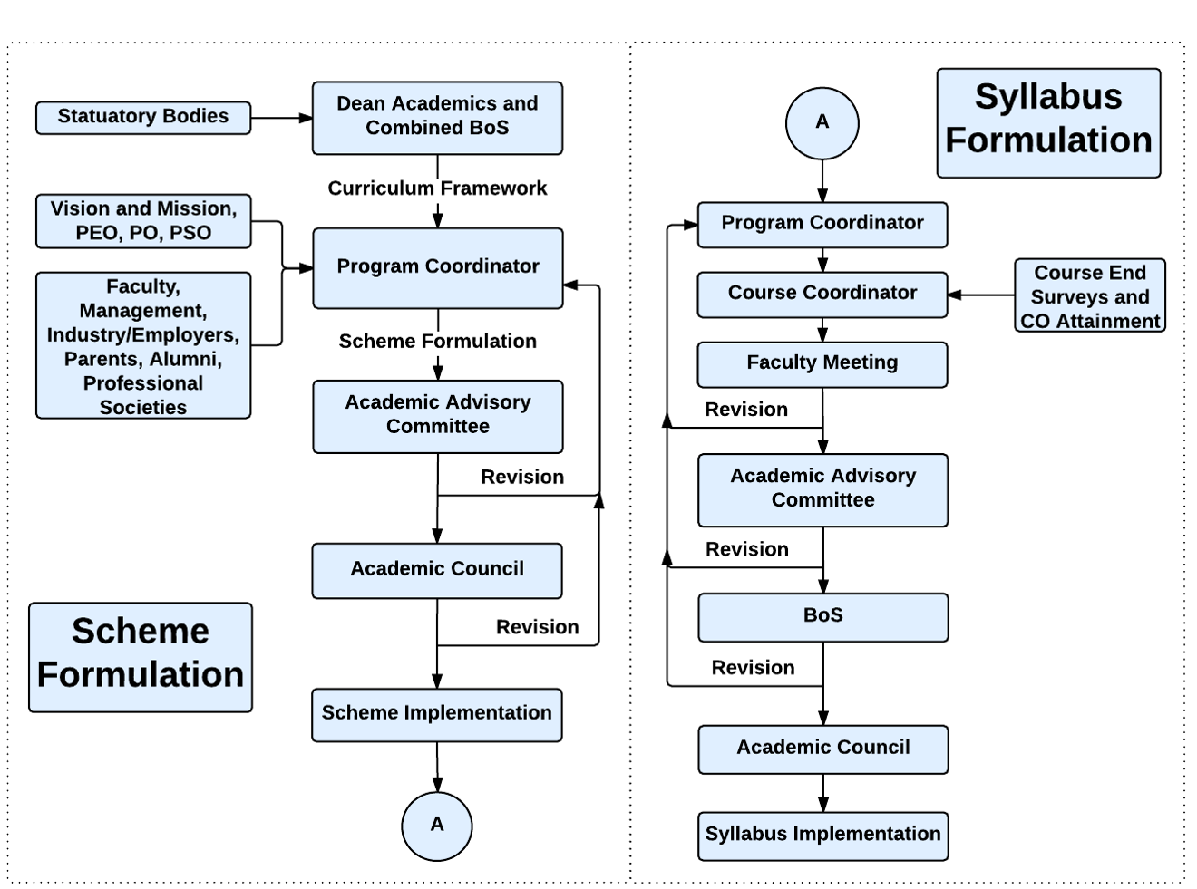

Academic Planning And Implementation
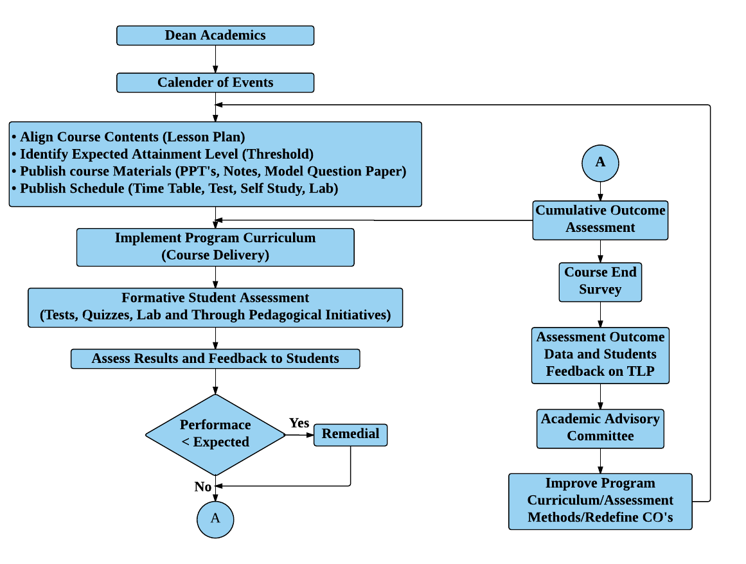

Process For Course Outcome Attainment
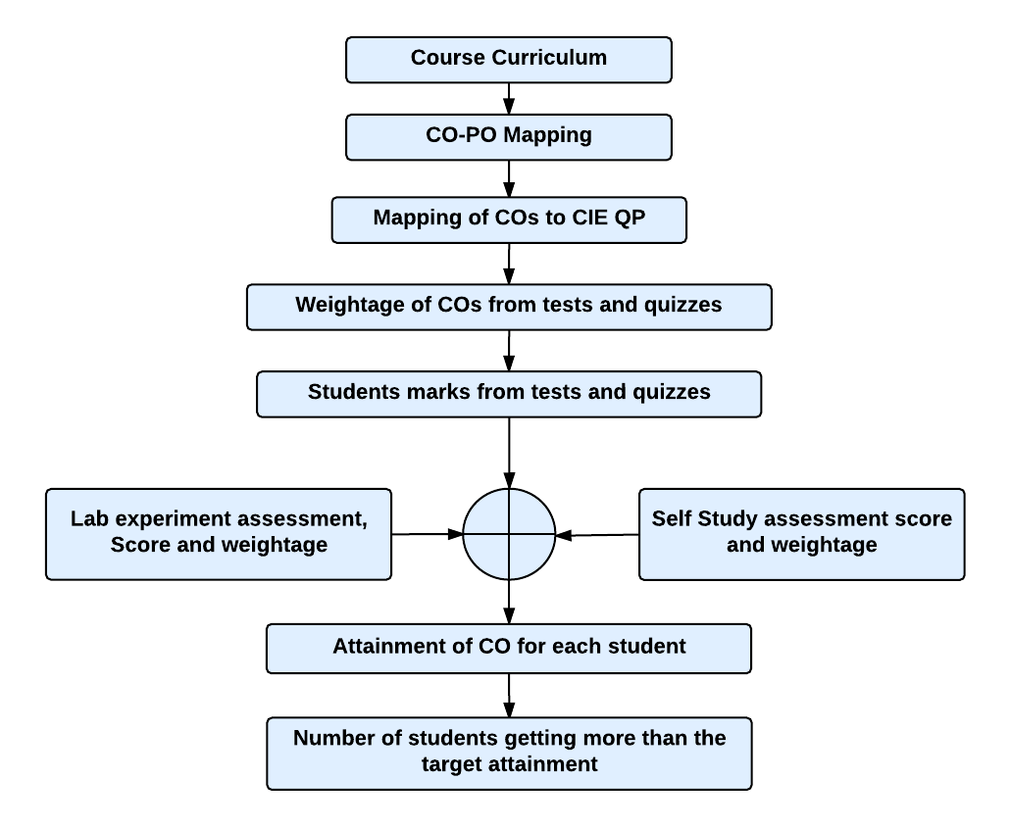

Final CO Attainment Process
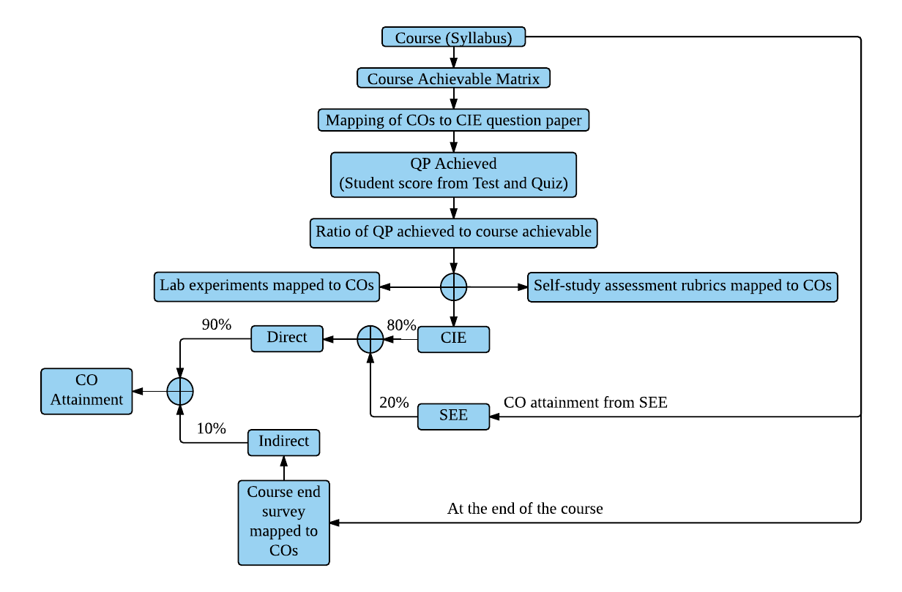
Program Outcome Attainment Process
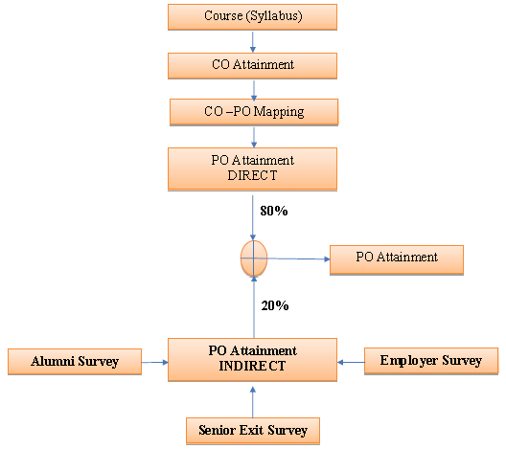

PROGRAM OUTCOMES (PO)
PO1: Engineering knowledge: Apply the knowledge of mathematics, science, engineering fundamentals, and an engineering specialization to the solution of complex engineering problems.
PO2: Problem analysis: Identify, formulate, review research literature, and analyse complex engineering problems reaching substantiated conclusions using first principles of mathematics, natural sciences, and engineering sciences.
PO3: Design/development of solutions: Design solutions for complex engineering problems and design system components or processes that meet the specified needs with appropriate consideration for the public health and safety, and the cultural, societal, and environmental considerations.
PO4: Conduct investigations of complex problems: Use research-based knowledge and research methods including design of experiments, analysis and interpretation of data, and synthesis of the information to provide valid conclusions.
PO5: Modern tool usage : Create, select, and apply appropriate techniques, resources, and modern Engineering and IT tools including prediction and modeling to complex engineering activities with an understanding of the limitations.
PO6: The engineer and society: Apply reasoning informed by the contextual knowledge to assess societal, health, safety, legal and cultural issues and the consequent responsibilities relevant to the professional engineering practice.
PO7: Environment and sustainability: Understand the impact of the professional engineering solutions in societal and environmental contexts, and demonstrate the knowledge of, and need for sustainable development.
PO8: Ethics: Apply ethical principles and commit to professional ethics and responsibilities and norms of the engineering practice.
PO9: Individual and team work: Function effectively as an individual, and as a member or leader in diverse teams, and in multidisciplinary settings.
PO10: Communication: Communicate effectively on complex engineering activities with the engineering community and with society at large, such as, being able to comprehend and write effective reports and design documentation, make effective presentations, and give and receive clear instructions.
PO11: Project management and finance: Demonstrate knowledge and understanding of the engineering and management principles and apply these to one’s own work, as a member and leader in a team, to manage projects and in multidisciplinary environments.
PO12: Life-long learning: Recognize the need for, and have the preparation and ability to engage in independent and life-long learning in the broadest context of technological change.

